Water Pollution in India: SAI India

“Every year, more people die from the consequences of unsafe water than from all forms of violence, including war”
1. Background and Audit planning
Significance of the topic
Clean, safe and adequate freshwater is vital to the survival of all living organisms and the smooth functioning of ecosystems, communities and economies. India’s 14 major, 55 minor and several hundred small rivers receive millions of litres of sewage, industrial and agricultural wastes. The most polluting source for rivers is the city sewage and industrial waste discharge. Presently, only about 30 per cent of the waste water generated is treated; the rest is discharged as it is into our water bodies. Due to this, pollutants enter groundwater, rivers and other water bodies. Agricultural run-off, or the water from the fields that drains into rivers, is another major water pollutant as it contains fertilizers and pesticides. The lakes and reservoirs all over the country, without exception, are in varying degrees of environmental degradation. Groundwater is generally less susceptible to contamination and pollution when compared to surface water bodies. But, in India, where groundwater is used intensively for irrigation and industrial purposes, a variety of land and water-based human activities are causing pollution of this precious resource.
Polluted water has the following impacts:
- On human health: Unsafe or inadequate water, sanitation, and hygiene cause approximately 3.1 per cent of all deaths – over 1.7 million deaths annually. Women, children and the economically disadvantaged are the most affected by water quality impacts. Over 90 per cent of those who die as a result of water-related diseases are children under the age of 5.
- On food production: Most polluted freshwater ends up in the oceans, damaging coastal areas and fisheries. Livelihoods such as agriculture, fishing and animal husbandry all rely on water quality as well as quantity.
- On biodiversity: Studies have estimated that the value of ecosystem services is double the gross national product of the global economy and the role of freshwater ecosystems in purifying water and assimilating wastes has been valued at US$ 400 billion. Freshwater ecosystems are among the most degraded on the planet and have suffered proportionately greater species and habitat losses than terrestrial or marine ecosystems.
As pollution of rivers, lakes and ground water impacts environment and biodiversity as well as public health and in light of increasing pollution of these sources reported, the topic, Water Pollution in India was chosen for audit. Further, the issue of water pollution had been flagged by leading environmentalists in India as one of the most important environment issues facing India.
2. Audit Scope, objectives, criteria
Audit scope
Audit took place at 2 levels: the central/federal level and state/provincial level.
At the central/federal level, audit scope covered policy and planning issues, data adequacy issues, issues relating to monitoring of measures to control pollution of rivers, lakes and ground water in India. The main federal ministry handling environment issues, called Ministry of Environment and Forests (MoEF) and the main ministry at the federal level for water issues called Ministry of Water Resources (MoWR) were audited to examine the above mentioned issues. Another agency at the federal/central level, responsible for water quality assessment, called Water Quality Assessment Authority (WQAA) was also audited.
At the state/provincial level, audit scope covered implementation and monitoring of programmes for the control of pollution of rivers, lakes and ground water by the designated implementing agencies. Further, at the state level/provincial level, audit scope also covered adequacy of planning to control water pollution, existence of accurate water quality data as well as impact of pollution control measures on quality of water in rivers, ales and ground water all over India.
Audit Objectives
- Inventory of water sources has been prepared and whether the overall status of quality of water in rivers, lakes and groundwater has been adequately assessed in India;
- Risks of polluted water to health of living organisms and the impact on environment have been adequately assessed;
- Adequate policies, legislations and programmes have been formulated and effective institutions been put into place for pollution prevention, treatment and restoration of polluted water in rivers, lakes and ground water;
- Programmes for pollution prevention, treatment and restoration of polluted water in rivers, lakes and ground water have been planned, implemented and monitored efficiently and effectively;
- Funds were utilized in an efficient and economic manner to further the aim of reduction of water pollution;
- Adequate mechanisms have been put in place by the government to sustain measures to tackle water pollution; and
- Programmes for the control of pollution had succeeded in reducing pollution levels in ground water and surface water and restoring water quality.
Audit criteria
- The Water (Prevention and Control of Pollution) Act, 1974
- Agenda 21 document of the World Commission on Sustainable Development of the United Nations Conference on Environment and Development, held in Rio in June 1992
- Guidelines for implementation and monitoring of National River Conservation Plan and National Lake Conservation Plan
- National Water Policy, 2002
- National Environment Policy 2006
- Implementation guidelines for Integrated Water Resources Management, specifically Integrated River Basin Management and Integrated Lake Basin Management
- Guidelines of United Nations Environment Programme (UNEP)
Audit sampling
We selected the audit sample on the basis of assessment of risks like expenditure, criticality of the project in pollution control and feedback received from the public to the advertisement placed in newspapers.
- Out of 1079 projects for pollution control of 24 rivers across 19 States being implemented, we audited 140 projects for 24 rivers.
- Out of projects for conservation of 58 lakes in 14 States, we studied 22 projects across 14 States.
- Out of a total of 6053 blocks across India, we examined 116 blocks for implementation and monitoring programmes relating to ground water pollution.
Audit also studied the administrative structures and activities related to water pollution in 25 States of India.
3. Methodology
For this particular audit, we adopted a very innovative methodology. The idea behind adopting innovative strategies was to reorient the conventional fault finding role of audit and play a more proactive role in the protection of the environment and thus contribute actively to this cause. Some of the innovative strategies being used in this report are as follows:
(i) Before commencement of audit
(a) Stakeholders’ Conference on Environment Audit: In July 2009, the office of the Comptroller and Auditor General of India organised a Stakeholders’ Conference on Environment Audit to flag major environmental issues in India and to identify significant areas for audit enquiry in the future. Experts from Civil Society organisations, from Ministries of Environment & Forests and Urban Development, from the Indian Meteorology Department and representatives/corporate bodies working in the field of environment attended the Conference. One of the major conclusions of this conference was that water, being an important environment issue, should be audited by SAI India.
(b) International Conference on Environment Audit-Concerns about Water Pollution: Once the topic had been identified during the Stakeholders Conference, we held a two-day International Conference on Environment Audit-Concerns about Water Pollution in March 2010 to discuss issues relating to water pollution. This conference was attended by members of various Civil Society Organisations, Government Agencies, International Agencies and Regulatory Bodies like Jheel Samrakshan Samity, Arghyam, Tarun Bharat Sangh, WaterAid India, Ministry of Environment and Forests, Central Pollution Control Board, Central Ground Water Board, Jammu & Kashmir Lakes & Waterways Development Authority, International Union for the Conservation of Nature, Food and Agriculture Organisation, GTZ etc., all of whom were working with water pollution issues. The Heads of Supreme Audit Institutions from Austria, Bhutan, Maldives and Bangladesh also shared their concerns about water pollution. The Conference flagged important areas of concern with regard to river, lake and ground water pollution which were then used to scope our audit as well as draw up our audit objectives.
The Comptroller and Auditor General of India will be conducting a Performance Audit on the subject “Pollution of ground water, lakes and rivers in India” during 2010-11. In case you want to draw attention to any specific problem/issue regarding water pollution which is affecting you or the environment around you, please get in touch with us. We would try to address these important issues in our report.
Email: cag.water@gmail.com
Postal address: Office of the Principal Director of Audit, Scientific Departments, DGACR Building, IP Estate, New Delhi 110002.
Fax No: 011-23702353

(c) Advertisement in newspapers: We put out advertisements in various national and local newspapers all across India, inviting suggestions from the general public regarding the water pollution problems faced by them. We received more than 500 e-mails and letters. All these inputs facilitated us in the framing of audit objectives, sub-objectives and questionnaires for our Performance Audit.
(ii) Collection of evidence
Once areas of audit enquiry and audit questions were framed, our audit methodology consisted of document analysis, responses to questionnaires, examination of reports & records at various levels to collect audit evidence.
(a) Use of detailed audit checklist: To facilitate our audit, since audit was to take place at the central/federal level as well as simultaneously in 25 states across India, we developed detailed questionnaires according to the agency being audited which guided audit at federal/central level as well as provincial level. This was an important method to ask all the right questions and to collect relevant and necessary audit evidence.
(b) Use of water quality testing to establish quality of water: Apart from all the evidence collected, audit also independently analysed samples of water in rivers, lakes and ground water sources which were in audit sample. This helped in independent verification of impact of water pollution measures on the quality of water in India’s rivers, lakes and groundwater sources.
An Entry Conference with the Ministry of Environment & Forests was held on 30 July 2010 wherein the audit objectives, scope of audit, audit criteria and audit methodology were discussed. Exit Conference on 6 June, 2011 was held with MoEF where audit findings were discussed.
4. Findings and recommendations
Audit findings
Legislative & Policy framework | - Water pollution has not been adequately addressed in any policy in India, both, at the federal/central and provincial/State level.
In the absence of a specific water pollution policy which would also incorporate prevention of pollution, treatment of polluted water and ecological restoration of polluted water bodies, government efforts in these areas would not get the required emphasis and thrust.
Planning for control of pollution in rivers, lakes & ground water | It was observed that the main ministry responsible for control of pollution at the federal level (MoEF) and a number of provinces/states had not carried out:  - Complete inventorisation of rivers/lakes and keystone species associated with them.  - Identification of existing pollution levels in rivers and lakes in terms of biological indicators.  - Identification and quantification of contaminants in rivers, lakes and ground water.  - Identification and quantification of human activities that impact water quality.  - Assessment of risks of polluted water to health and environment  - Had not adopted the basin level approach for control of pollution of rivers and lakes  - Had not developed water quality goals, corresponding parameters for each river/lake and failed to enforce these.
As such, overall planning for the control of pollution on by federal/central as well as provincial/state authorities falls short of an ideal situation. This would have repercussions on implementation of programmes for control of pollution and their outcomes as discussed later in the report.
Implementation of programmes for control of pollution in rivers, lakes & ground water | - Current programmes for control of pollution of rivers, lakes and ground water were insufficient.  - Institutional set-up to manage programmes for control of pollution in rivers, lakes and ground water was inadequate.  - Inclusion of rivers and lakes into programmes for control of pollution in rivers and lakes was flawed.  - Performance of projects undertaken to prevent pollution of rivers was unsatisfactory. 82 % of such projects were completed after the scheduled date of completion. 28 projects costing ` 251.27 crore were constructed but not utilised as yet. Provinces/states implementing the projects faced problems in land acquisition, getting requisite permissions, especially forest clearances, technical problems, problems from contractors etc.  - Programme to prevent pollution of lakes has been ineffective in achieving the objective of conservation and restoration of lakes in India. Only two of the sampled 22 projects had been completed and the rest were either continuing beyond the sanction date of completion or had been abandoned. Problems like resistance from locals over proposed construction of sewage treatment plants etc., dispute over site, inability to arrest sewage flow, non-availability of land etc., have contributed to non-completion of the projects.
Thus, programmes to control pollution of rivers and lakes in India have not had the desired results.
Monitoring of programmes for control of pollution of rivers, lakes & ground water | - Inspection and monitoring of projects being implemented for prevention of pollution of rivers and lakes was inadequate at all three levels, i.e., local level, provincial/State level and federal/Central level.  - There was paucity of network for tracking pollution of rivers, lakes and ground water as there were inadequate number of monitoring stations, no real- time monitoring of water quality was taking place and the data on water quality had not been disseminated adequately.
As such, monitoring of programmes was inadequate which points to weak internal controls existing at all levels of government.
Results of programmes for control of pollution in India | River cleaning and control of pollution programmes for polluted rivers are being implemented since 1985. The programmes seek to address pollution from point and non-point sources through construction of Sewage Treatment Plants, low cost sanitation, electric crematoria etc. However, the data on the results of these programmes are not very encouraging. Rivers like Ganga in certain stretches, Yamuna, Gomti, Godavari, Musi, Cauvery, Cooum, Mahananda, Khan, Kshipra, Vaigai, Chambal, Rani Chu, Mandovi, Sabarmati, Subarnarekha, Bhadra/Tungabhadra, Pennar, Pamba, Betwa, Krishna, Sutlej etc., continue to be plagued by high levels of organic pollution, low level of oxygen availability for aquatic organisms and bacteria, protozoa and viruses which have faecal-origin and which cause illnesses.  Most lakes in India are under threat from nutrient overloading which is causing their eutrophication and their eventual choking up from the weeds proliferating in the nutrient-rich water. Implementation programmes for preventing pollution of these lakes has had no discernible effect. Lakes like Pichola, Pushkar, Dimsagar, Banjara, Kotekere, Bellandur, Veli Akkulam, Shivpuri, Powai, Rankala, Twin lakes, Bindusagar, Mansagar, Mansiganga, Rabindra Sarovar, Mirik, Kodaikanal lake, Dal lake, Durgabari lake, Laxminarayanbari Lake, Dimsagar Lake etc., still have very poor water quality.
The data on the results of pollution control programmes for lakes and rivers is not very encouraging, especially with respect to rivers. Rivers like Yamuna in Delhi, Sabarmati in Gujarat and Musi in Andhra Pradesh are virtually dead rivers.
However, there have been some success stories with respect to prevention of pollution of lakes like Nainital lake, Kotekere lake, Sharanabasaveshwara lake and Mansagar lake where water quality has improved after completion of conservation programmes.
Resources & Utilisation of Funds | Funds available for control and prevention of water pollution and restoration of wholesomeness of water were not adequate and neither were they utilised according to laid down rules and procedures.
Overall conclusion | We began the audit of Water Pollution in India with certain audit objectives which sought to examine the broad contours of policy, programmes, institutions and initiatives taken by federal and provincial agencies to address water pollution in India. We also sought to examine availability of data regarding water pollution, assessment of risks to health and environment and sustainability of measures to address water pollution in India. Finally, we also examined whether the efforts to clean up rivers and lakes in India have lead to any improvements in water quality. Our audit examination extended to 140 projects across 24 polluted stretches of rivers, 22 lakes and 116 blocks across 25 States of India. All the findings, lead us to conclude the following against the objectives set out for the study:  - Inventory of water sources has not been prepared and the overall status of quality of water in rivers, lakes and groundwater has not been adequately assessed in India;  - Risks of polluted water to health of living organisms and the impact on environment have been not been adequately assessed;  - Adequate policies, legislations and programmes have not been formulated and effective institutions have not been put into place for pollution prevention, treatment and restoration of polluted water in rivers, lakes and ground water;  - Programmes for pollution prevention, treatment and restoration of polluted water in rivers, lakes and ground water have not been planned, implemented and monitored efficiently and effectively;  - Funds were not utilised in an efficient and economic manner to further the aim of reduction of water pollution;  - Adequate mechanisms have not been put in place by the government to sustain measures to tackle water pollution; and  - Programmes for the control of pollution have not succeeded in reducing pollution levels in ground water and surface water and restoring water quality.
Recommendations
- Federal level agencies, in their policy on water pollution, need to specifically take into account prevention and control of water pollution as well as ecological restoration of degraded water bodies.
- Federal level agencies specially Ministry of Environment and Forests should initiate steps, along with Ministry of Water Resources and all the States to draw up a comprehensive inventory of all rivers, lakes and ground water sources in India. They should also undertake a survey to list all the keystone species associated with each river and lake in India. This should also be placed in the public domain.
- The main ministry at the federal level for pollution related issues (MoEF) responsible for control of pollution should intensify its efforts in developing biological indicators which would shed light on whether the functional integrity of aquatic ecosystems are safeguarded.
- The main ministry at the federal level for pollution related issues (MoEF) should take into account the basin approach while planning for reduction of pollution of all rivers and lakes in the country.
- The main ministry at the federal level for pollution related issues (MoEF) needs to establish enforceable water quality standards for lakes, rivers and ground water that would help protect human and ecosystem health. Penalties need to be levied for violations of water quality standards. Further, MoEF, in conjunction with Ministry of Agriculture, needs to develop standards for pollutants like nitrogen, phosphorus etc., which arise from agricultural practices, use of pesticides and fertilisers as pollution from agricultural sources is one of the biggest non-point source of pollution.
- Right now, there are multiple agencies involved in river and lake conservation, right from planning to implementation and monitoring. There is a need to consolidate all these functions under an umbrella agency for better coordination and accountability.
- Federal and provincial level agencies need to ensure that projects for source control of all kind of pollutants entering the lakes is included in projects for conservation and restoration of rivers and lakes, especially sewage and agriculture runoff which leads to nutrient over-loading of the lake.
- The main ministry at the federal level for pollution related issues (MoEF) should ensure that all lakes facing encroachment and resultant filling up are included in programme for prevention of pollution of lakes. Further, all State governments should declare bio-conservation zones around lakes so that encroachment of shoreline is prevented.
- The Water Quality Assessment Authority at the federal level and the Water Quality Review Committee in the provinces should be revitalized and strengthened so that it can act as a cross-sectoral nodal body for water pollution issues.
- States should involve citizens in proposing and monitoring programmes to control pollution of rivers and lakes. This will help in mobilizing support in civil society for the proposed projects and thus the projects will face less resistance from local people.
- Citizens Monitoring Committee and Local level lake monitoring committees need to be constituted to provide feedback for more effective implementation.
- Monitoring network should be strengthened by converting all monitoring locations into stations and reclassifying them as baseline, trend and flux stations for achieving better quality data. MoEF should also start real time monitoring so that red flags are raised immediately when pollution levels rise alarmingly and remedial action can be taken in time

5. Impact and results
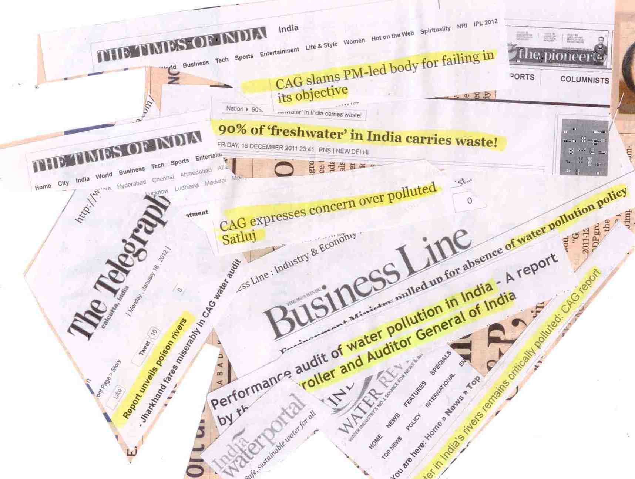
The report was presented to the Parliament in December 2011 and was widely reported in the press. At the time of the exit conference to discuss the audit report, MoEF committed to set up a committee to draw up a roadmap to implement audit recommendations in the report. The Committee consisted of representatives of MoEF and Ministry of Water Resources, Ministry of Urban Development and a representative of CAG. The Committee in came out with proposals like a time-bound action plan to address capacity issues related to sewage treatment, an amendment to the Environment (Protection) Act, 1986 to link penalties for contravention of the Act, strengthening of Water Quality Assessment Authority, constitution of a State-level Monitoring Committee etc., to implement the recommendations made by SAI India in its report.
Newspaper reports on SAI India's audit
6. Challenges faced during audit

- Lack of data regarding pollution levels in rivers/lakes
- Absence of some records pertaining to implementation of the projects, specially those which were more than 5 years old
- Multiplicity of authorities dealing with programmes to prevent pollution of rivers and lakes; as a result, lines of communication were not very clear.
- Coordination of audit which was simultaneously taking place in 25 states/provinces
- Some of the concepts relating to control of pollution were scientific in nature. So auditors had to be trained and given exhaustive material so as to better acquaint them with technical issues in water pollution.

7. Lessons learned

- Immense value addition through consultations with external stakeholders and those working in the field before choosing a topic.
- Placing advertisement in newspapers gave us a very good indication of the scale and dimensions of the issues involved in the audit.
- Providing at least one complete year from planning the audit to preparing the report.

Nameeta Prasad,
Director,
International Center for Environment Audit and Sustainable Development (iCED),
Jaipur
SAI India.

As assessed by Millennium Ecosystem Development Report (2005).

