Cooperation on environmental auditing:
Transregional Capacity Building Programme for Performance Audits of Environmental Issues in Forestry 2010-2012
MATULEE YOKEE

Environmental issues related to forestry have become a prevailing global challenge across nations and accordingly also a concern of Supreme Audit Institutions (SAIs). SAIs play an important role to promote environmental governance by carrying out environmental audits on their government’s environmental commitments. Therefore, the IDI has launched a capacity building programme on performance audits of environmental issues in forestry in cooperation with the INTOSAI Working Group on Environmental Audit (WGEA).
The objective of this programme is to enhance both professional staff development and institutional capacity of target SAIs in performance audits of environmental issues in forestry. Target is 15 SAIs from three different INTOSAI regions, namely AFROSAI-E, ASOSAI and CAROSAI.
This programme consists of 6 projects to be executed during 2010-2012. As follows:
- Programme Planning Meeting
The IDI, the WGEA and subject matter experts discussed and agreed on the overall programme design and details of activities.
- Online Development of Draft Audit Plans
Audit teams were guided in a step-by-step approach by subject matter experts to develop a draft audit plan on 2-3 prioritized audit topics.
- Audit Planning Meeting
A two week planning meeting was held to introduce the WGEA Forest Audit Guideline and finalize the draft audit plan. During this meeting the draft audit plans, developed by the teams, were discussed and reviewed by peers and experts. By the end of the planning meeting each SAI team had a finalized audit plan ready for approval by the respective SAI.
- Pilots Audits in SAIs
The SAI teams carried out a performance audit of environmental issues in forestry as per their approved audit plan. They were supported by expert teams during the planning stage. The expert teams provided online support through the yahoo platform used in the online development of draft audit plans. The audit teams were encouraged to share their experiences and challenges with other SAI teams.

- Review Meeting for finalization of audit reports
At the review meeting the draft audit reports of the SAIs were reviewed, discussed and finalized. During the meeting, there was also discussions and feedback on the WGEA Forest Audit Guideline, draft forest audit case studies, and draft compendium report compiling audit findings, recommendations and challenges withdrawn from the pilot audits.
- Wrap up and Follow up Meeting
After the review meeting, the wrap up meeting was held by the IDI, the WGEA and team of experts to write a lesson learnt document and finalize outputs of the Programme.
OAG Thailand only participated in 4 projects-- Online Development of Draft Audit Plans, Audit Planning Meeting, Pilots Audits in SAIs, and Review Meeting for finalization of audit reports.
◎ Online Development of Draft Audit Plans
Step 1 – Preparation
The audit team had to understand about the entity business process and profile by collecting some data and information, analyzing those data and information and conducting interview or discussion with the entity management in order to identify risks.
Step 2 – Select the Audit Topic
The objective of this step is to select relevant and prioritized audit topics to be carried out by audit teams in their pilot audit.
From the collecting some data and information of Thailand’s audit team, the risk which had less Government Risk Management (GRM) and Internal Control System (ICS) are Illegal Used of Land and Conflict Risk. But the first two priorities which were selected risk were Illegal Used of Land and Illegal Logging, after we had considered the effectiveness of the GRM and ICS, the significance or impact of the risk, the frequency of the risk to happen which based on the executive interview, and the information about the serious problem of the forest management in Thailand.
From the Audit Topics Matrix in the Forest Audit Guideline, two risks are related to seven sub topics as follows:
- Forest Policy
- Permanent Forest Estates
- Forest Ownership
- Protection
- Legal Arrangements
- Monitoring and Research
- Economic, Incentives and Taxation
After we had considered the sufficiency and effectiveness of the GRM and ICS include with information from interviewing the executives officers of entities and the past audit reports of OAG Thailand, three sub topics were considered in this audit;
- Forest Policy
- Permanent Forest Estate
- Forest Ownership

Step 3 – Develop Audit Design Matrix
The audit team had to develop the audit design matrix which consists of 8 columns: Audit Objective, Researchable Question (RQ), Sub Researchable Question (SRQ), Criteria, Audit Evidence, Audit Methodology, Limitation, and What This Analysis Will Likely to Say.
Thailand’s audit team developed the audit design matrix for each of 3 selected audit topics.
Step 4 – Develop Audit Calendar
The audit team developed the audit calendar which consists of the activities, the time schedule per each activity and the person in charge for each activity.
◎ Audit Planning Meeting
In this project, the Forest Audit Guideline was introduced by WGEA. During this meeting the draft audit plans, developed by the teams, will be presented, discussed and reviewed by peers and experts before being finalized. By the end of the planning meeting each SAI team will have a finalized audit plan ready for approval by the respective SAI.
For OAG Thailand, the audit topic selected to audit is Permanent Forest Estate by focusing on the forest demarcation.
◎ Pilots Audits in SAIs
The SAI teams carried out a performance audit of environmental issues in forestry as per their approved audit plan. During the audit the expert teams provided online support through the yahoo group used in the online development of draft audit plans. The audit teams were encouraged to share their experiences and challenges with other SAI teams.
◎ Review Meeting for finalization of audit reports
At the review meeting the draft audit reports of the SAIs were reviewed, discussed and finalized. The SAI team shared SAI’s plan to institutionalize the audit capacity after completion of the Programme. And, there was discussions and feedback on the WGEA Forest Audit Guideline, draft forest audit case studies, and draft compendium report compiling audit findings, recommendations and challenges withdrawn from the pilot audits.

Permanent Forest Estate: Forest Demarcation

The objective of the national forest policy is to maintain the forest area at least 40% of the country area (204,800 sq.km. approximately) which is divided into 25% of the protective forest and 15% of the productive forest in order to increase rain absorption and to balance the demand of timber. Moreover, the national forest policy defines more than 35% of the area with slope is forest land which the issuance of deed or certification of utilization is prohibited in these area. Anyhow, the total forest area in Thailand was 172,185 sq.km. or 34% of the country in 2007.
Encroachment, which derives from economic growth, increased tourism, population growth, and agricultural price control, affects to the demand for cultivated land that is the main reason of deforestation.
The ambiguous forest demarcation is the main reason of conflict in land use between forest agencies and other relevant agencies, or between government agencies and surrounding people while the forest agencies still can not manage or solve this problem.
Audit Objectives
- To determine whether the forest demarcation of 3 departments has been clear and covers
- To assess whether the land demarcation is in harmony with the surrounding people
The Scope of Audit
The scope of audit of “Permanent Forest Estate: Forest Demarcation” is to audit the forest demarcation during 2002-2011 of 3 departments under Ministry of Natural Resources and Environment (MNRE) which are responsible for the forest management. The mentioned 3 departments are as follows;
- the Royal Forest Department (RFD)
- the Department of National park, Wildlife and Plant Conservation (DNP)
- the Department of Marine and Coastal Resource (DMCR)
Audit Methodology
Many tools for data collecting and information both primary data and secondary data were used as follows;
- Document Review; all data and information about forest demarcation were reviewed.
- Audit Sampling; the total number of forest in Thailand are 1,462 forests. We selected the sample of forest amount 65 forests under responsibility of those 3 departments to audit.
21 Selected forests are Reserved Forest under RFD
35 Selected forests are Conservative Forest under DNP
11 Selected forests are Mangrove Forest under DMCR
- Interviews; In-depth interview were conducted with the executives, authorities, and officers, whose work concerned to the responsibility in forest demarcation and forest management from 3 forest agencies as the central office and group discussion interview at the regional office in order to collect the problem and recommendation of forest demarcation and forest management in Thailand. To interview the executives, authorities, and officers of other relevant agencies as shown in appendix 3 involved in forest demarcation, to collect the problem and recommendation of forest demarcation among agencies.
And interview the surrounding people who live in or nearby the forest in order to collect the problems and conflict between people and officers.
- Questionnaire; the questionnaire was designed by the audit team for the executives, authorities, and officers who participated in group discussion to know the condition and limitation in forest demarcation including recommendation.
- Observation; the observation was planned to collect the primary data of observed areas related to the position of boundaries, the condition of forest area, the condition of encroachment, the condition of boundary marking/sign, etc.
- Experts; as the forest demarcation is very complicated issue. It requires experts and specialist who have experience in GPS, GIS and Remote sensing technology. However, the knowledge in this field in OAG was not yet sufficient, thus OAG hired 2 consultants to support the audit team.
- Analyzing audit results; the audit team has implemented as the following the process;
- Listing all discovered problems during audit
- Analyzing the relations of problems and their breaking down into Cause – Problem – Outcome and draft audit report
The duration of Audit
From October 2010 to September 2011

Forest Audit Finding

In Thailand, three agencies have responsibility for the forest management under MNRE. RFD is responsible for productive forest that is 1,221 Reserved Forests. For the protective forest, DNP is responsible for 123 National Parks, 58 Wildlife Sanctuaries, and 60 Non-Hunting Areas. DMCR is responsible for Mangrove Forest 1,270 polygons.
The audit in forest demarcation of RFD, DNP, and DMCR found that the forest demarcation has not been defined clearly and covered; the boundary markings were inefficiency and ineffectiveness; the forest demarcation is unacceptable of the surrounding people; and there were many Ground Control Points in the same area with different standards. The details are as follows:
Finding 1: The forest demarcation has not been defined clearly and covered.
The forest boundaries and coordinates of forest demarcation in Thailand are still not clear and do not cover all forests. The forest boundaries rectified by different officers are difference because there is no standard of rectification. Moreover, the forest boundaries shown in the map annexed the law differed from the boundaries protected by the officers; did not cover the watershed area; and overlapped inhabited area or responsibility area of other agencies. The causes are the gazetted map in some forests was sketched on map without ground checking and the coordinates were not identified.
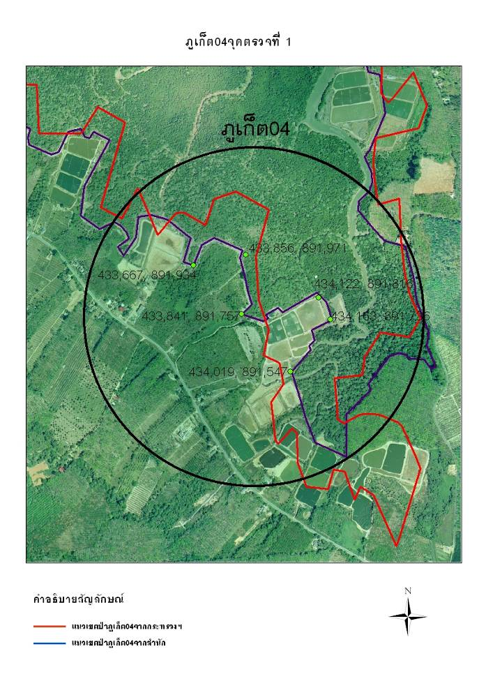
Figure 1: The different forest boundary caused by the rectification of different officer.
The red line is the rectified boundary by officer of consultancy firm which was hired by MNRE.
The blue line is the rectified boundary by officer of consultancy firm which was hired by DMCR.
Place: PK 04, Phuket Province.

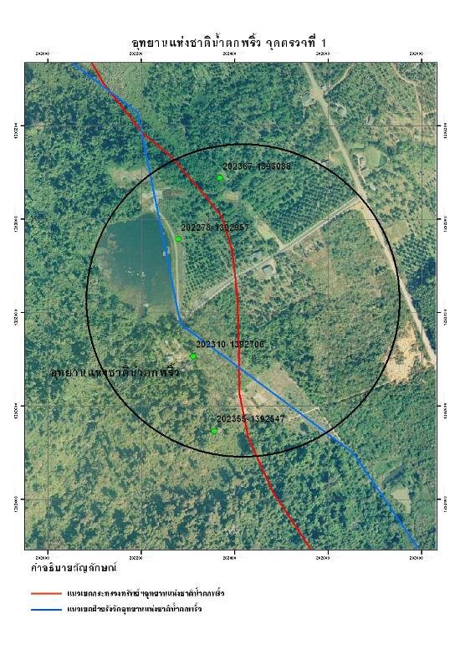
Figure 2: The forest boundary in gazetted map had differed from the forest boundary which the officer protected.
The red line is the boundary in gazetted map.
The blue line is the rectified boundary by DNP’s officer. By consider the protected area of local officer in rectification.
The left side of the red line is Namtok Phlew National Park. The red circle shows that the red line does not cover National Park Protection Unit 4 (Namtok Makok) while the blue line considering the protected area covers it.
Place: Namtok Phlew National Park, Chanthaburi Province.

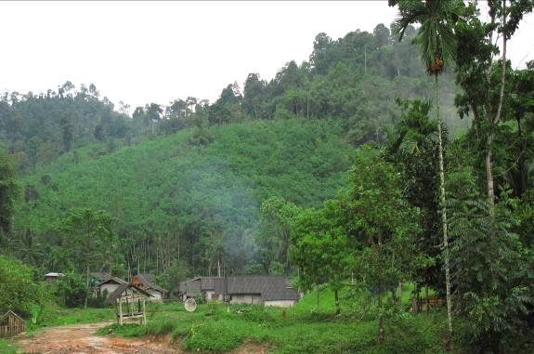
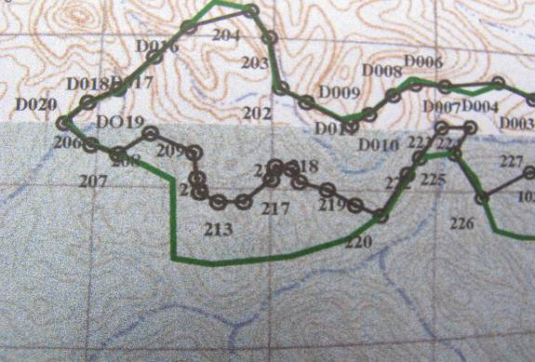
Figure 3-4: The forest boundary did not cover the watershed area.
The red ovals are outside Khlong Yun Wildlife Sanctuary but they are slope area over 35%, and they are the source of watershed area, which supposes to be forest land.
The red arrows point the forest area that its slope over 35% but it is outside Khlong Yun Wildlife Sanctuary. Nowadays, this area is rubber plantation.
Place: Khlong Yun Wildlife Sanctuary, Surat Thani Province.
Date: March 23, 2011

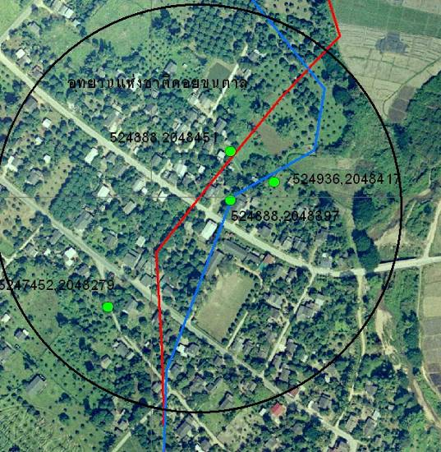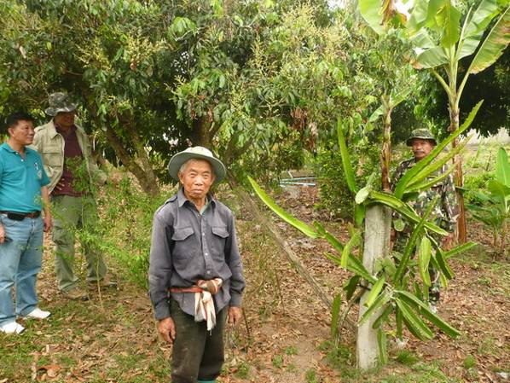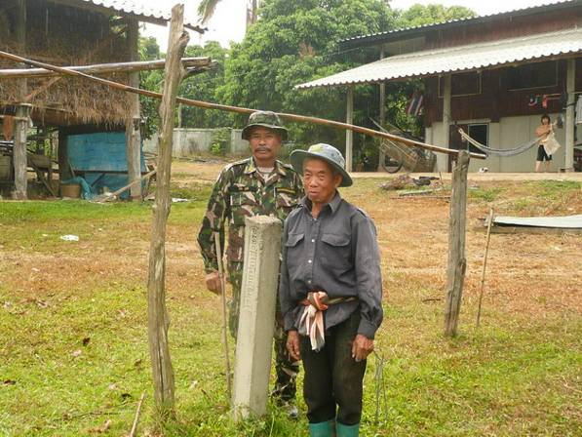
Figure 5-7: The forest boundary in gazetted map overlapped inhabited area.
The left side presents the observation point which is in Doi Khun Tan National Park.
The right side presents the pillar posted in inhabited area and agricultural area. Behind the pillar is Doi Khun Tan National Park.
By the top-right side presents dragon fruit tree planted on the pillar.
From interviewing the person in this picture, he informed that he had settled down in this area before it was declared as a National Park.
Place: Doi Khun Tan National Park, Lampang Province. Date: March 12, 2011

Recommendations for this audit finding are the government has to operate as follows:
1. Determine the policy, assign the main agency to clear the forest demarcation, command the relevant agencies to integrate the information and set the action plan in the same direction and standard.
2. Determine or declare the direction of proceeding against invaders and proceeding in overlapped areas by being fair with the surrounding people.
3. Determine the method for proving the land ownership and issuing the land tenure by proving the land tenure together with ground survey.
4. Review the target of forest area in the National Forest Policy, especially the protective forest, to be consistent with the actual condition.
5. Determine the main responsible agency to Thailand's land management and empower that agency to command and manage the relevant agencies.
6. Set up the committee or working group from the persons who have knowledge, ability and experience in forest demarcation to review and ground check the process of forest demarcation. Furthermore, in province areas, the provincial governor should participate in the forest demarcation and the boundary problem resolution.
7. Assign the forest agencies to integrate forest demarcation with regard to information, instruments and staffs.
8. Command the adjustment of the forest boundary and revise the forest boundary on map annexed the law.

Finding 2: The boundary markings were inefficiency.
The boundary markings in some sampled forests were inefficiency because they did not sufficiently cover, especially, the risk area of encroachment and the boundary markings were made several times in the same area due to a lack of an integrated database concerning forest boundary markings among forest agencies or in the area having natural feature. Moreover, the issue of boundary markings which could not be posted was not reported, leading to having a risk of fraud in operation.
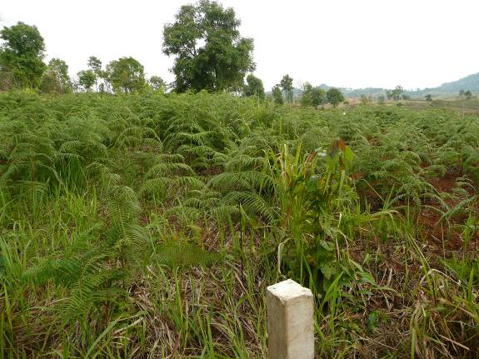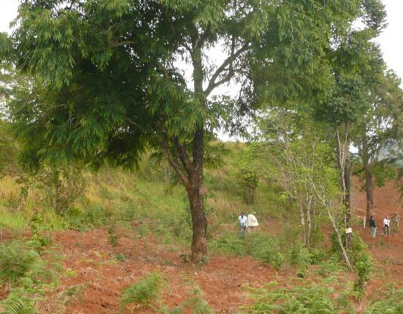
Figure 8-9: On the left side, red oval is tree which has boundary signs. The red line shows boundary which separates the forest land with private land. On the left of red line is forest land, whereas on the right is private land. In this picture, the macadamia plantation was cultivated by encroaching upon the forest.
On the right side shows the tree, which is marked the forest boundary, within the red oval of left picture.
Place: Lan Sang National Park, Tak Province. Date: March 16, 2011

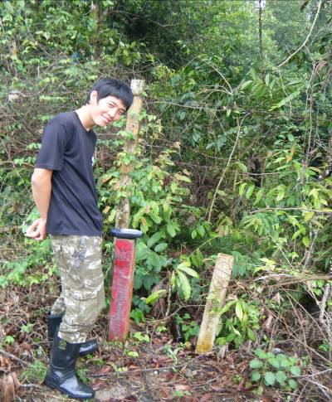
Figure 10: Too many of boundary markings were posted in same area. In this figure, 2 pillars were posted by DNP and DMCR in same area because of the overlapping area.
Place: Sirinat National Park and PK02, Phuket Province.
Date: April 1, 2011

Recommendations for this audit finding are forest agencies have to emphasize setting up the boundary markings at sharply bent point and the area having the risk of encroachment, clear forest boundary to eliminate overlapping problem, integrate information of forest demarcation, set the internal control system, and verify the accuracy and transparency of the boundary marking activity.
Finding 3: The forest demarcation is unacceptable of the surrounding people.
From observation found that the boundary markings were pulled down beside the holes by the surrounding people who claimed the land right because they had settled down and cultivated there before the land was gazetted as a forest. This demonstrates disapproval of the surrounding people towards the forest demarcation.
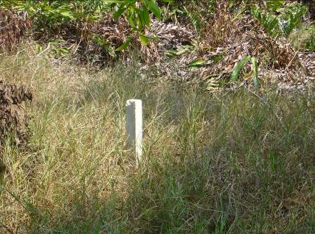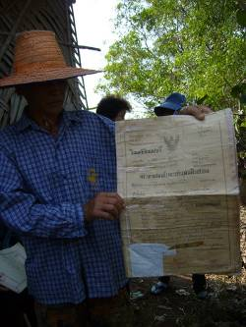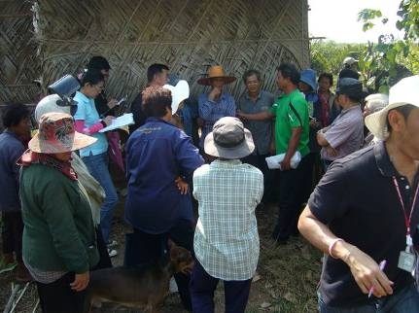
Figure 11-13: The left side is the pillar which was post in the inhabited area where the surrounding people have had deed since 1932. These surrounding people did not participate in forest demarcation, thus they do not accept forest boundary.
Place: CHT 14, Chanthaburi Province Date: February 18, 2011

Recommendations for this audit finding are the forest agencies have to focus on the public relations with the surrounding people to make understanding and acceptance in the forest boundary. Moreover, the public participation is an important process which will make the surrounding people recognizes the objective of the boundary markings and cooperates with the forest agencies to protect the forest.
Finding 4: There were many Ground Control Points in the same area with different standards.
There are many government agencies which set up GCPs for their operation in Thailand. From observation found that many GCPs were set up in the same area without integrated GCPs information. Therefore, the budget was spent inefficiently and abundantly.
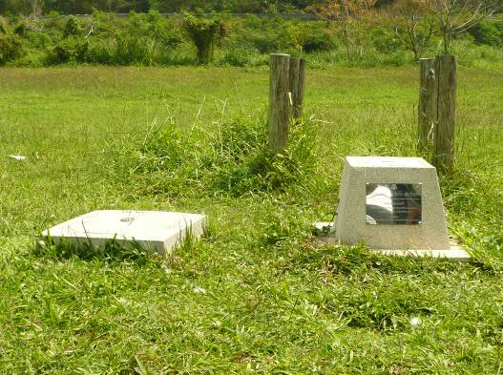
Figure 14: The left side is GCP of MNRE and the right side is GCP of DNP. They were set up in the same area.
Place: Doi Pha Muang Wildlife Sanctuary, Lampang Province.
Date: March 12, 2011
Recommendations for this finding are the government has to command to revise the available GCPs to be on the same standard and revise the coordinates of GCPs for accuracy and reliability. Moreover, the government has to assign the main responsible agency to integrate all GCPs data of Thailand and allow other agencies to take GCPs data for using in operation and planning in order to eliminate redundancy in setting up new GCPs.

Lessons learned: Transregional Capacity Building Programme for Performance Audits of Environmental Issues in Forestry 2010-2012

From this programme, we learned the performance audit of environmental issues in forestry by following the Forest Audit Guideline and using the Audit Topics Matrix to select the audit topic. And, we got advice from the forestry experts. This programme gave a chance to share ideas and experience in environmental audit. We learned about the audit technique and the audit report pattern of other SAIs. Our draft report were discussed and reviewed by peers and experts, which increased the quality of the finalized report. Furthermore, the yahoo platform which was provided to support the online audit of this programme was the good channel for SAIs to learn and develop their tasks.

Senior Auditor, Performance Audit Office, Office of the Auditor General of Thailand

