COUNTRY PAPER
The 5th Seminar On Environmental Audit And 4th Working Meeting Of ASOSAI WGEA
15-17 April, 2014, Hanoi, SR of Vietnam.
“Audit on Solid Waste”

I. Overview.
Environmental issue in currently which people around the world give more importance and attention for socio-economic development in trend are green to sustainable development.
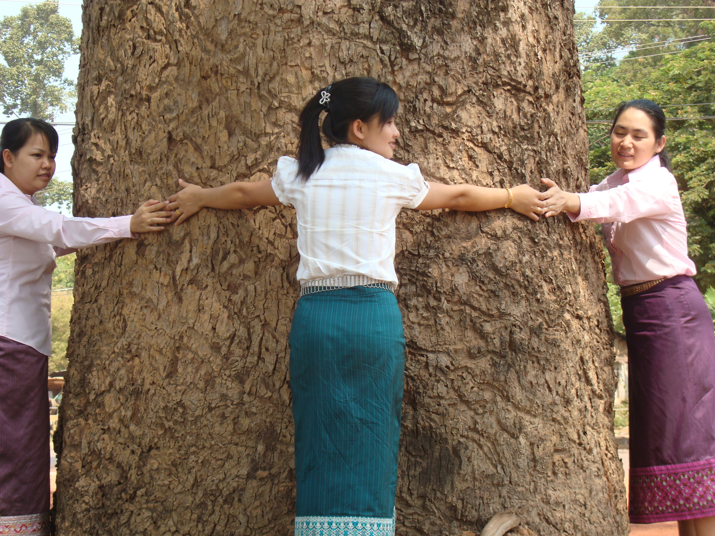
To ensure sustainable development, protection and management on natural resource and environmental, Lao PDR pay a great attention which has policy to promote a local-intellectual based economy associated with the management, the most effective use nature resources, and sound protection of the environment by focus in protection quality on water, soil, mining and air are ongoing to ensure the environment quality meets the national environmental quality standard.

II. Audit Scope.
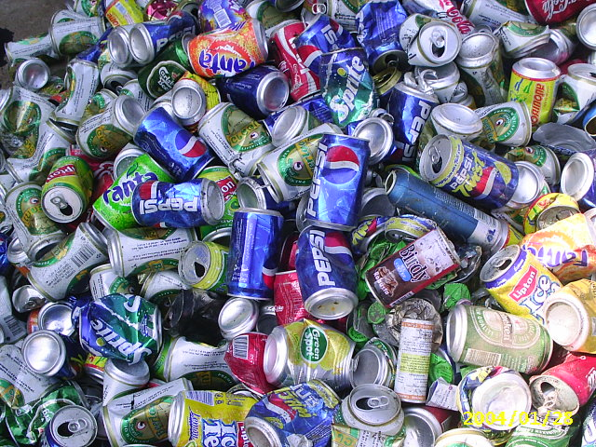
To evaluate the government operation for the problem solving on the solid waste impact from the natural and man-made include: solid, liquid or gaseous, toxic or non toxic waste exceeding their respective prescribed standards and leading to negative impacts on human health, human life, animals, plants and the environment in Vientiane Municipality.
- kinds of Solid wastes include:
+ kinds of Plastic: bottle of water, plastic bag and etc…..
+ kinds of Paper: paper boxes, books, newspapers and Mechanizes
+ kinds of Can: can of fruit juice, milk and etc….
+ kinds of Glass: bottle of fruit juice, beer and other beverage
+ kinds of other wastes: bone, meat, leather, feather and etc….

III. Audit entities.
The entities that audit team work with are:
1. Ministry of Natural Resource and Environment included: the Cabinet, Department of planning and cooperation, Department of Water Resource, Department of Environment Quality Promotion, Department of Pollution control, Department of Environmental and Social Impact Assessment, Resource and Environment Institute, Lao national Mekong Committee Secretariat and Natural Resource and Environment Information Center.
2. Urban Development and Administration Authority of Vientiane included: Administration Sector, plan-finance Sector, Urban Housing Sector, Bridge-Load management Sector, Allocate sector, Solid Waste Collection Service Unit, Clean and Decorate Sector and Landfill management Unit.
IV. Audit Objectives.
1. The assessment of compliance in the implementation policies, laws, strategies plan and other regulations of Ministry of Urban Development and Administration Authority (UDAA) in solid waste management specific.
2. The assessment of the implementation of UDAA in solid waste management specific.
V. Legal or Criteria in Audit.
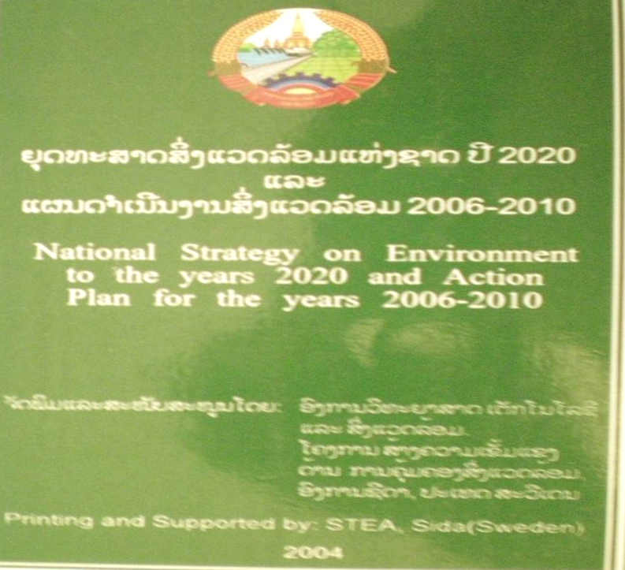
Existence of legal and regulation are law, resolution, decree, strategy plan, and other regulations for using the implementation on manage and protection natural resource and environment.
1. National strategy on environment to the years 2020 and action plan for the years 2006-2010.
2. National strategy on environment education and awareness to the years 2020, and action plan for the years 2006-2010.
3. Environmental protection law.
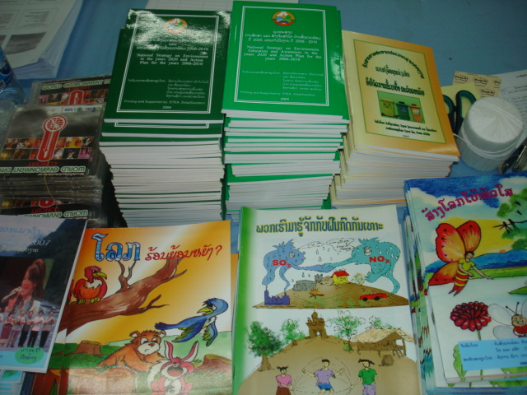
4. Decree on the implementation of the environmental protection law.
5. Introduce guidance about the collect and information system management of international Mekong River committee
6. Decision on the national environmental standard.
7. Decree on the Environmental Impact Assessment.
8. Guideline on biodegradable solid waste issue 2007.
9. Guideline on Solid Waste Management and Protection on Environment.
10. And other regulations.
VI. Audit methodologies.
+ The methodologies audit team used follow as:
- To conduct Research and analysis other information received from auditee.
- Interview or questionnaire from staffs in Ministry of Natural Resource and Environment
and Urban Development Administration Authority of Vientiane
- Site visit for monitoring, inspect and take photos some places are markets, schools,
Hospitals, construction area and canals in Vientiane.

+ Audit Procedures.
The audit team had work plan and conducted audit work as follows:
 Preparation for the audit: to make survey, collect, analysis information and other regulations to segregation of duties, assess risk of information and etc.. to selection specific entities for auditing.
 The preparation of audit program (Audit Design Matrix)
 The conduct of audit
 Prepare draft audit report to submit to concerned parties as appropriate.
VII. Audit Finding and Recommendations.
1st Finding: After assessment of staff statistic fiscal year 2010-2011, there are not enough specific Technical staffs that have knowledge and capacity environment especially solid waste management mission, which is cover only 2% total amount of staffs.

2nd Finding: The Mobilize, disseminate approach, policy plan, law and regulation about the solid waste management for society in attention on protection environment such solid waste collection and disposal by making contract solid waste collection service with UDAA, although implemented but statistic of household who use the service it still cover only 34% in 36,193 of household.

1st Recommendation:
UDAA should attention to create; improvement and promotion about enhance level Knowledge and capacity for technical staffs in their office on environment management especially solid waste management mission to make it more effective and efficient.

2nd Recommendation:
Therefor, to avoid the burn, throw another places or wrong disposal method, UDAA should more attention in the mobilize, disseminate information, awareness and training for society acknowledge to important on environment and impact of solid waste in daily life, include campaign, policy of implementation and law about environment mission.

VIII. Audit Results.
- Ministry of Natural Resource and Environment

Generally, Natural resource and environment organization attention to implementation of their role, rights and duties as stipulated in degree issue No. 149/Po, Date 10 may 2007 Such as:
- Attention to research, create, advise and implement laws, degree, strategies plan, short
term, middle term and long term plan and other standard related to natural resource and environment mission.
- Attention to research, create, improve other regulations and legislation not completed or
Compliance with socio-economic development in each period.
- Attention to create sustainable plan, protection and rehabilitation natural resource and
environment.
- Awareness around the society to acknowledge in conservation on natural resource and
environment in various activities as: in special days of nation, newspaper, radio, television and etc…..
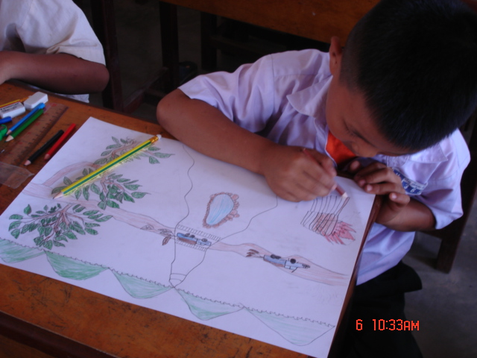
- Checked, certified and adopted the environment and social impact assessment report before approve to conduct project development and other activities.
- Relation and corporation with other sectors and local level to ensure both of development and protection natural resource and environment in every area around the country.
- Management, collect and provide
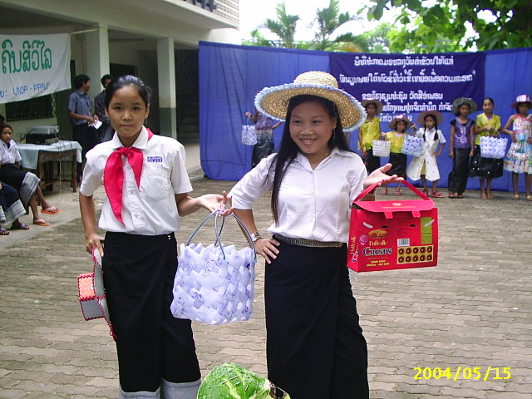
information about natural resource and environment in country.

- Relation and competition to contribution and cooperation with oversea and international organization for manage and development.
- Make and implementation human resource, natural resource and environment development plan.
- Reward any individual, person and organization having achieved exempla performance in the implementation of the protection natural resource and environment.

- Urban Development and Administration Authority of Vientiane.

Generally, leader of UDAA give more attention to implementation of their assignment by
Role, rights and duties, each sectors and units focus in well done implementation and each step of authority’s cooperation in the conservation on environment, especially the mission is solid waste management.

IX. Weakness or Challenge include:

 Lack of specific technical staffs who have knowledge, capacity and Experience in Audit environment.
 Not enough of budget and equipment in the monitoring and inspection.
 Implementation of some projects not well such as: awareness project, monitoring and inspect of the manage and protection natural resource and environment project.
 The mobilize people in attention on protection water resource and environment not well, some households not yet to use the service of Urban development administration authority (UDAA), still to burn and throw another places.
 The promote private company to attention on investment as: construction the standard landfill, kiln, recycle, collect service, transport and disposal not well.

