Country Paper of
OAG Thailand

By : Anchaleekorn Pravarana &
Yupaporn Kaibuddee

Brief Introduction of Thailand.

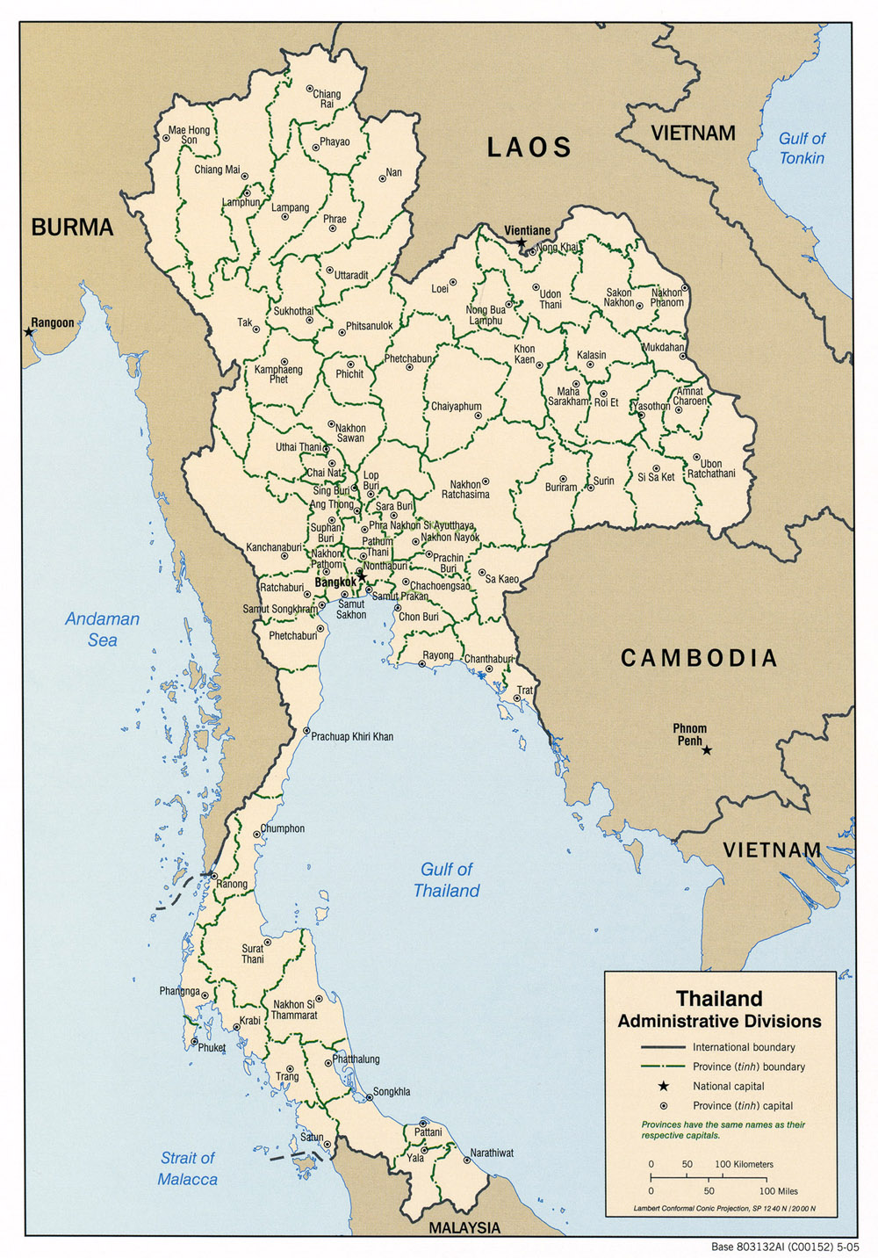
Thailand, formerly known as Siam, is a country located at the centre of the Indochina peninsula in Southeast Asia. It is bordered to the north by Burma and Laos, to the east by Laos and Cambodia, to the south by the Gulf of Thailand and Malaysia, and to the west by the Andaman Sea and the southern extremity of Burma. Its maritime boundaries include Vietnam in the Gulf of Thailand to the southeast, and Indonesia and India in the Andaman Sea to the southwest.
The country is a constitutional monarchy, headed by King Rama IX, the ninth king of the House of Chakri, who, having reigned since 1946, is the world's longest-serving head of state and the longest-reigning monarch in Thai history. The king of Thailand is titled Head of State, Head of the Armed Forces, the Upholder of the Buddhist religion, and the Defender of all Faiths.
Thailand is the world's 51st-largest country in terms of total area, with an area of approximately 513,000 km² (198,000 sq mi), and is the 20th-most-populous country, with around 65 million people. The capital and largest city is Bangkok, which is Thailand's political, commercial, industrial and cultural hub. About 75% of the population is ethnically Thai, 14% is of Chinese origin, and 3% is others. The country's official language is Thai. The primary religion is Buddhism, which is practiced by around 95% of the population.

Brief Introduction of OAG Thailand.

History

In 1875 under the absolute monarchy, the Royal Audit Office was established in order to control the public finance of Siam. (Siam is the previous name of Thailand.)
In 1915, the Inspection Department was set up in order that audited collecting revenue and inspected public expenditure.
In 1932 when the country changed to democracy rule, The inspection department was transferred to be a new and independent agency under the Office of the Prime Minister namely “Office of the Auditor General of Thailand”
Based on Audit Council Act B.E. 2476 (1933), Siam established the Audit Council as an institution accountable for financial government audit.
In 1979, Thailand revised the Law on Audit Council and enacted State Audit Act B.E. 2522 (1979). This law improved and expanded the audit authority to the performance audit.
However, in 1999 the State Audit Act was improved again as the Organic Act of State Audit B.E. 2542 (1999) under the constitution of Kingdom of Thailand which the State Audit shall be carried out by the State Audit Commission and the Auditor General who is independent and impartial.
Presently, OAG Thailand is one of constitutional organs under the Thai Constitution 2007 which composed the State Audit Commission, the Auditor General and the office of the Auditor General. OAG has reported directly to the parliament.

Development of Our OAG

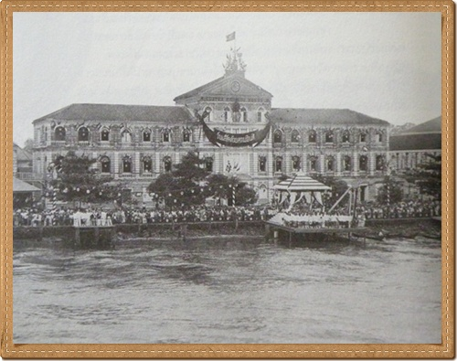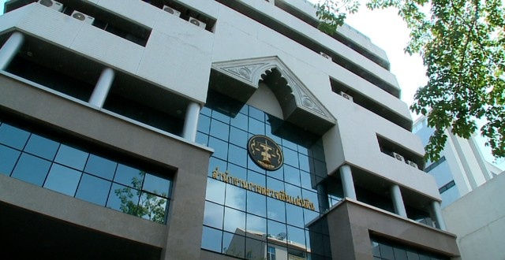

Authorities and duties of The State Audit Commission.

- To determine standards relating to State audit.
- To provide opinions, suggestions and recommendations for the correction of faults in State audit.
- To appoint the independent Fiscal and Financial Disciplinary Committee.
- To render decisions on actions relating to fiscal and financial discipline, finance and budget and the cases of dispute in relation to the decisions of the Fiscal and Financial Disciplinary Committee.

The Auditor-General shall have the powers and duties in relation to State Audit and shall be independent and impartial.

Under Article 39 (2) of the Organic Act of State Audit B.E. 2542 (1999),OAG Thailand has the authorities as follows;
- To audit the statement on receipt and payment.
- To audit the currency reserve account.
- To audit the receipt and payment, the custody and disbursement of money and uses of other properties belonging to the audited agencies.
- To examine in the connection with the collecting revenue of audited agencies.
However, OAG will give the opinions whether audited agencies are in compliance with law, rules and regulation also value for money.

Audit Types of OAG Thailand

- Financial-Financial Audit, Accounting Audit and Voucher Audit.
- Compliance-Public Procurement Audit and Investigative Audit.
- Value for Money-Performance Audit.
- Other-Environmental Audit, Audit of Collecting Revenue and Special cases Audit.

Case study of BMA’s activities to control air quality

I. Background and audit planning
Air pollution is one of the major environmental issues in Bangkok
due to rapid growth in number of motor vehicles. It causes direct environmental impacts and serious effects on public health. Respiratory illnesses are caused by particulate matter with diameter less than 10 microns (PM₁₀) or dust from emission of motor vehicles with incomplete combustion, uncovered construction sites, and emission from industrial plants or other
establishments. Air pollution is more severe in roadside areas than in other
areas.
As a result, Bangkok Metropolitan Administration (BMA) set 3 main strategies to control air quality in Bangkok:
1. Control and reduce pollution from motor vehicles by imposing strict penalty measures on pollutant generating vehicles and any vehicle need to be complied with environment quality before license plate renewal.
2. Control and reduce pollution from other sources by keeping registry records of sources of pollution, monitoring pollution levels and encouraging
clean technology application.
3. Encourage the air quality monitoring through records of air quality
measurement to be maintained at acceptable standard.
From these strategies, BMA has begun many activities to control air quality. The Office of the Auditor General of Thailand (OAG) reviewed 3 activities to control air quality of BMA.
1. Reviewed the implements activities of BMA to detect, monitor and impose restrictions on motor vehicles emitting black smoke. BMA, the Traffic Police Division and Pollution Control Department have set up 50 emission check points with data-link with the vehicle registration database
of Land Transport Department. The smoke detection data link system improves emission detections via real-time emission data records and data
link-up with the central database at BMA for decision making to solve air pollution issues. It also connects with the vehicle registration of Land Transport Department. If the motor vehicles have black smoke. The Land Transport Department officers are inspect and prohibit use of vehicles follow The Enhancement and Conservation of National Environmental Quality Act, B.E. 2535.
2. Reviewed the implements activities of BMA to road dust control by dust vacuuming and cleaning of roads and footpaths of 50 district offices.
3. Reviewed the implements activities of BMA to increase of application of strict rules on covering of construction sites and trucks and washing of vehicle tires before leaving sites of 44 sites in 5 district offices.
BMA used 1,000,000 USD per Year for conducting 3 activities. Although the activities used a small budget but if they are succeed , BMA will able to decrease some PM₁₀ ,that is a part of causes of air pollution.
For these reasons, OAG selected the activities to control air quality of BMA to review the result and impact to the environmental.
Initially, OAG determined the audit scope to examine the detect, monitor and impose restrictions on motor vehicles emitting black smoke of 50 emission check points in 2009, road dust control of 50 district offices in 2009 and monitoring construction sites and trucks and washing of vehicle tires before leaving sites of 44 sites in 5 district offices during 2007-2009. Under their target, OAG employed it as the audit criteria. The audit objective is to determine whether the activities to control air quality of BMA achieved the target.

II. Methodology
For the audit methodology, the audit staff has collected 2 types of data.
1. The primary data : questionnaire, interview and observation.
2. The secondary data : review documents from BMA and analysis.
For primary data detail are shown in the table below:
Methodology | Source
Questionnaire | 50 directors of 50 district offices.
Questionnaire | 140 Traffic Polices who work in the areas that the PM ₁₀ higher than a standard.
Interview | The director of Air Quality and Noise Management Division, Department of Environment of BMA and 2 staff of the division.
Observation | 44 construction sites in 5 district offices.
Though these methods are done in a simple fashion, it can point out the risk of measures to control air quality of BMA.

III. Finding and Recommendations
OAG has found 3 major findings which indicate the weakness of BMA 's measures to control air quality.
(1) District offices have not reported the result of black smoke detection through the BMA data link system.
(2) BMA has not determined the criteria for district offices to define the frequency of road cleaning in each areas.
(3) The majority of construction contractors have not implemented in compliance with BMA 's measures.

(1) District offices have not reported the result of black smoke detection through the BMA data link system.
BMA has set up the black smoke detection target in year 2009 to accomplish the task district office and traffic police have to closely work in the field together monthly and report the black smoke detection result through the system from the total of 50 district offices.
It was found from the audit that 2 district offices from the total of 50 have cancelled the black smoke checkpoint. Among the 48 district offices that implement the black smoke detection, there is only one of them that report the detection result through the BMA data link system. The details are shown in the table 1.
Table 1 : Showing the number of district office that implement the black smoke detection and reporting.
Source : Air Quality and Noise Management Division, Department of Environment of BMA.
The number of district office |  |  | Total
Implement black smoke detection. |  | Do not implement black smoke detection. | Total
Report through the system. | Do not report through the system. | Do not implement black smoke detection. | Total
1 | 47 | 2 | 50
OAG has recommend BMA to corporate and consult with traffic police to determine the implementation guideline for smoke detection and to instruct the district offices to focus on the evaluation of smoke detection in order to take the evaluation result to improve their working performance.

(2) BMA has not determined the criteria for district offices to define the frequency of road cleaning in each areas.

BMA should set the criteria for district offices to increase the frequency of road cleaning for better response with the dust trouble in each district offices.
It was found that BMA has not determined the criteria for district offices to define the proper frequency of road cleaning in each areas in order to reduce the dust. As a result the frequency of road cleaning in many district offices are indifferent even though the dust trouble in each areas are much different.
In year 2007 - 2009 the PM₁₀ in the inner areas was much wisher those in the middle areas as suburb but the average of road cleaning per month for all areas is only less than 10 time per month. The details are shown in the table 2.

Table 2 : Showing frequency average of road cleaning per month in year 2007 – 2009.
Frequency average of road cleaning per month  2007 - 2009 | Inner area | Middle area | Suburb area | Total
 |  |  |  | The Number frequency average of road cleaning | percentage
1-10 | 12 | 17 | 5 | 34 | 68.00
>10-20 | 5 | 4 | 1 | 10 | 20.00
>20 | 5 | 1 | 0 | 6 | 12.00
Total | 22 | 22 | 6 | 50 | 100.00
Source : Air Quality and Noise Management Division, Department of Environment of BMA.

OAG has recommend BMA should set the criteria of the road cleaning standard for district office. So, the district office could use this criteria as a guideline to higher the road cleaning frequency. The district office should also conclude the result of its for each district offices work to the executive monthly.

(3) The majority of construction contractors do not implement in compliance with BMA 's measures.

BMA measures to control air quality prescribes that the construction contractors in BKK area are compulsory to prepare a space for cleaning up the construction vehicles. Covering the dust items or keep them in the closed areas and sprinkling water on top to prevent the dust.
According to the observation of 44 construction sites in inner BKK , areas of 5 district offices in year 2009, it was found that most of contractors are not complying to BMA measures. The details are shown in the table 3.

Table 3 : Showing implementation in accordance with BMA measures for construction site in BKK in year 2009.

BMA measures to control dust in construction site | The result of measures |  |  |  | Total
BMA measures to control dust in construction site | Control dust in construction site |  | Do not Control dust in construction site
BMA measures to control dust in construction site | Number of sites | percentage | Number of sites | percentage | Number of sites | percentage
Prepare the proper space and equipment for vehicle cleaning and prevent the area around. | 38 | 86.36 | 6 | 13.64 | 44 | 100.00
Cleaning the vehicle body and wheel before exit the construction site. | 23 | 52.27 | 21 | 47.73 | 44 | 100.00
Covering the dust items or keep them in the closed area. | 25 | 56.82 | 19 | 43.18 | 44 | 100.00
Sprinkling water on the dust items to prevent dust. | 30 | 68.18 | 14 | 31.82 | 44 | 100.00
Source : The observation of OAG.

OAG has recommend that BKK should place an importance on air pollution control by sending staff to closely and continually monitor the construction site and also publicize and inform the contractor to realize the trouble caused by PM₁₀.

IV Impact and result
(1) What actions were taken to respond to audit results?
BKK has implement in according to the OAG recommendations;
- BKK has set up the meeting with related Government entities, Department of land transport , Pollution Control Department on 17th August 2011 to find the solutions to improve the effectiveness and efficiency of black smoke detection plan in 50 districts of Bangkok.
- BKK has firmly instructed the staff of district offices to go to the field work with traffic police and report the results through the BMA data link system. The district offices also have to constantly evaluate the result of smoking detection. Plan to improve their working performance.

(2) Were there any environmental benefits as a result of the audit
and government’s action?
The air control management of BMA is slightly better after the audit. Though BMA has implement in accordance with OAG’s recommendations, it does not have much effect an overall air quality in BKK. This is because there are so many factors and many related entities effecting the effectiveness and efficiency of air control. The details are shown in the table.
Table : Showing comparison the result of air quality examination in year 2009 and 2013.
The result of air quality examination in year 2009 |  |  | The result of air quality examination in year 2013
The number of examination | PM₁₀  >Standard | percentage | The number of examination | PM₁₀  > Standard | percentage
1,709 | 326 | 19.08 | 1,879 | 350 | 18.63
Source : Air Quality and Noise Management Division, Department of Environment of BMA.

V Challenges and barriers

The audit has randomly done in some BMA dust control activities. Beside BMA there are many government entities, that are responsible for air quality control such as Department of land transport, Pollution Control Department. The real challenges for OAG is to properly conduct the audit to determine whether the dust control activities in many entities are done in real efficiency, effectiveness and economy.

VI Lessons learned

Air quality management is not only the work of particular government agency but it is the main concern for all units in society : Government private sector community family and all individuals. We might have to invest a large amount of money at first to effectively control air quality. It's work, it could save a have cost of public health and it will worth every dollars we spend for the public health in the long run.

