Country paper_SAI Afghanistan_PA & EA
Introduction
Municipalities in Afghanistan are one of the most important entities providing services to the residents both in metropolitan cities and provinces. The major duties of municipalities include: providing living facilities, maintenance and building new greeneries and expansion of these green areas, providing sanitation services and availing cleanliness of living environment, healthy environment, building streets, building health clubs, shopping centers, cultural centers, maintenance of streets and alleys, possessing lands, distribution of residential lands and etc.
The expenses of operations of municipalities are self-donated through selling the residential and commercial pieces of land, land tax, rents, parking tickets, entrance tolls, selling drafts, duties of some services, tax on floor plans, penalties, billboards duties etc.
The budget of municipality is made up of two types: operational budget and development budget which are donated as per below:
- Operational budget is donated from 45% of the municipality fixed revenue.
- Development budget is donated from 55% of the municipality fixed and unfixed revenue and from the account the municipality has in the bank.
Article 12, municipality law, the revenue of municipality belongs to municipality itself and will donate its operational expenses from this revenue.
The revenue aforementioned will be kept in designated account for municipality.
Importance of this audit
Kabul the capital city of Islamic Republic of Afghanistan is one of the most populated cities in Afghanistan. Approximately 5 million people live in this city, most of whom migrated from the provinces and this trend keeps going up. Kabul Municipality has structured many projects for welfare of its increasing population which include following services: environmental cleanliness, waste management, refineries, streets, water canals, deranges, pavements, markets, general parks, gardening and greenery, burying the waste and etc.

Audit Criteria
The amount of the budget spent against budget allocated and budget appropriation, ability of sanitation personnel, the way activities and transactions done so that the weather pollution is mitigated, pollutants of environment, maintaining a healthy environment, observance of environmental criteria, waste management, cooperation in greenery activities, cleaning canals, maintenance of streets and alleys, activities of environmental auditing in respect to municipalities in accordance with performance audit criteria which is obtained from international standards of ISSAI’s (300, 3000, 3100, 3200) and environmental audit standards in ISSAI’s (5110, 5120) in line with procedures, laws and environmental regulations.
Audit Scope
The performance and environmental audit covers the performance and transactions of Kabul Municipality during the solar years 1391-1393 and its audit practically started on 1/10/1393 (Dec. 22,2014).
The main focus of the performance and environmental audit is on weather pollution, environment pollutants, maintaining healthy environment, observing the environmental standards, waste management and greenery and financial control, human resource control, procurement and contracts management, management of operations, internal audit system, issues related to regulations, laws and procedures and etc.

Methodology applied
The performance and environmental audit methodology includes review of documents and financial transactions of Kabul Municipality and 3 entities under its authority, analysis of financial information and other information, evaluation of their performance and environment effects in accordance with international environment standards, comparing their performance with practices prevalent in other countries, obtaining the vision and opinions of Kabul Municipality authorities, observations, figures and recommendations, physical verifications and interviewing the residents.
Audit Observations
- Leading sewerage of 12th district of Kabul City into a large puddle irresponsibly
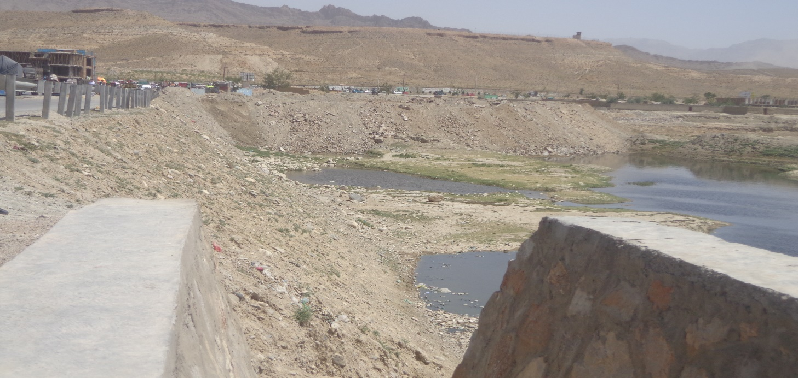Kabul Municipality, went into a contract with Faqir Rahmani Construction Company for managing the sewerage into Kabul River, but it was noticed that in an area about 190 meters away from Kabul River, the sewerage was disposed of into a big puddle irresponsibly.
Picture #1: Leading sewerage into a puddle
The amount of the budget spent against budget allocated and budget appropriation, ability of sanitation personnel, the way activities and transactions done so that the weather pollution is mitigated, pollutants of environment, maintaining a healthy environment, observance of environmental criteria, waste management, cooperation in greenery activities, cleaning canals, maintenance of streets and alleys, activities of environmental auditing in respect to municipalities in accordance with performance audit criteria which is obtained from international standards of ISSAI’s (300, 3000, 3100, 3200) and environmental audit standards in ISSAI’s (5110, 5120) in line with procedures, laws and environmental regulations.
Lack of monitoring over KM’s projects and weak internal controls over contract management resulted in signing contract with an ineligible construction company.
Over a certain period of time, stable sewerage in the puddle causes bad smell, different disease, increasing insects and contaminating underground water.
Recommendation
It is recommended that KM makes the construction company strictly abide by the provisions of the contract and remove the puddle.

- Crowded packs of homeless dogs increased the probability of rabies in entire Kabul city
In physical visit of auditors from different districts in Kabul city, a lot of homeless dogs were seen.
Sanitation personnel, the way activities and transactions done so that the weather pollution is
mitigated, pollutants of environment, maintaining a healthy environment, observance of environmental criteria, waste management, cooperation in greenery activities, cleaning canals, maintenance of streets and alleys, activities of environmental auditing in respect to municipalities in accordance with performance audit criteria which is obtained from international standards of ISSAI’s (300, 3000, 3100, 3200) and environmental audit standards in ISSAI’s (5110, 5120) in line with procedures, laws and environmental regulations.
Rabies is a highly fatal disease that the infected person will hardly be cured and mostly dies. Lack of an effective program for removing homeless dogs and having no exact statistics about the number of cases of bitten dogs severed the situation.
Recommendation
It is recommended that KM in coordination with Curative Health Directorate and Ministry of Agriculture carry out an effective program to remove the homeless dogs and mitigate the risk of rabies in the city.

- Kabul River placed huge amount of Trash
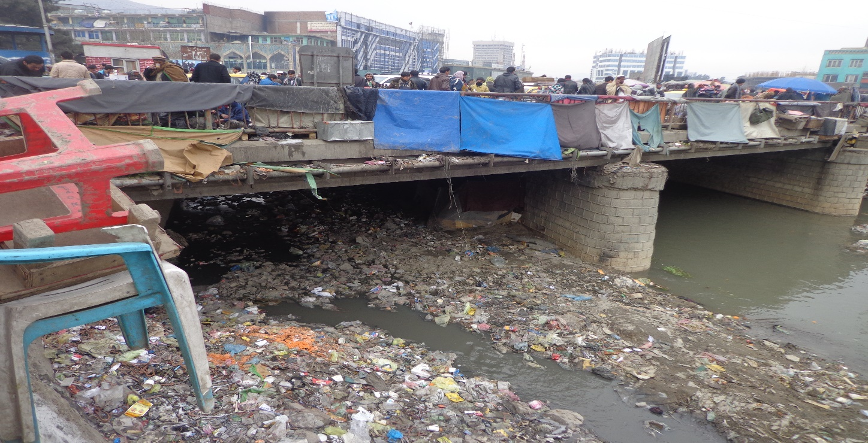Based on survey conducted by Kabul Municipality, it was noticed that there are approximately 1835 sub-pipes and home sewerage led into Kabul River that pollutes the underground water.
Picture #2: Leading trash and sewerage into Kabul River
The amount of the budget spent against budget allocated and budget appropriation, ability of sanitation personnel, the way activities and transactions done so that the weather pollution is mitigated, pollutants of environment, maintaining a healthy environment, observance of environmental criteria, waste management, cooperation in greenery activities, cleaning canals, maintenance of streets and alleys, activities of environmental auditing in respect to municipalities in accordance with performance audit criteria which is obtained from international standards of ISSAI’s (300, 3000, 3100, 3200) and environmental audit standards in ISSAI’s (5110, 5120) in line with procedures, laws and environmental regulations.
The trash and sewerage in Kabul River will all gather together in an area outside the city namely Sorubi and will produce poison and prohibits utilization of water resource for production of power.
Recommendation
It is recommended that KM should use its power for prohibition of leading trash mostly by government offices into Kabul River so that to mitigate the risk of poisonous substances and dirtiness of the river.

Conclusion
Since the PEAD is newly stablished department (established in late 1391) it didn’t have a lot of experience regarding carrying our environment audit. However in its first audit conducted in KM, it came up with handful observations in compliance with International auditing standards.
It’s important to mention that Afghanistan has the National Environmental Protection Agency who is working independently and has Environmental Law, Environment Strategy, Regulation on Controlling Materials Destructive to the Ozone Layer, and National Environmental Impact Assessment Policy, NEPA and SAI coordination is a little weak with each other.
It is expected that the intended course on Environmental Auditing help the participants become familiar with most common practices experienced in other countries and share the experience each participant had in audit field.

