
^{COUNTRY PAPER}

FOR

6 ^{TH} Seminar on Environmental Auditing and
5 ^{TH} Working Meeting of ASOSAI WGEA
17- 19 October, 2016
At International Centre For Environment Audit
And Sustainable Development, Jaipur, Rajasthan India

BY

Ms. Nomjit Sungdanjak
Senior Professional Auditor
Mr. Nattawut Chuisamrarn
Professional Auditor

Office of the Auditor General of Thailand

Theme: Audit on the Implementation of Environmental Policy

Performance Audit on
Permanent Forest Estate: Forest Demarcation
Background information
The Forest Act (1941), Section 4, prescribed “forest” as land that has not been taken up or acquired by any other means according to land law, and all forest and forest land are state property. The major national forest policy in Thailand is the national forest policy B.E. 2528 (1985) which was approved by the Cabinet on January 22, 1985. This policy is determined to cover most concerned aspects in forestry and determines the forest areas across the country at least 40% of the whole area which is divided to 25% of the protective forest and 15% of the productive forest. Furthermore, the government announced the cancellation of logging concession in B.E. 2532 (1989).
In the past, the number of population in Thailand was a few and forest area was vaguely scattered throughout the country. Later, the increased population causes logging and burning forest in order to expand agricultural area then there is deforestation and reduction of forest area from 43.33% in 1973 to 33.44% in 2008.
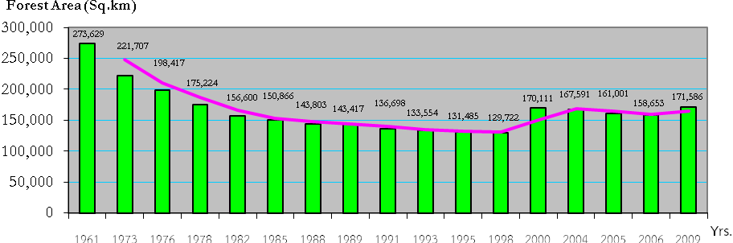
Source: Forest Land Management, RFD
Classification of Forest
To classify the forest in Thailand according to the responsibility of forest agencies, it can be classified into 2 types as follows;
- Protective Forest is forest area which is assigned to conserve environment---soil, water, rare species of plant and animal. Including natural disaster protection from flooding, soil collapse along with to study or research about forest. Protective Forest is divided into
    - National Park means any area of land, the natural features of which are of interest and to be maintained with a view to preserving it for the benefit of public education and pleasure. Include land with beautiful landscape important history, and rare plant or animal species. It was prescribed in the Royal Decree on the National Park Act B.E. 2504 (1961).
    - Wildlife Sanctuary means any area which is declared for the conservation of wildlife, so the wildlife can freely breed and increase their population in the natural environment. It was prescribed in the Royal Decree on the Wildlife Preservation and Protection Act B.E. 2535 (1992).
    - Non-hunting Area means any area which is prohibited hunting any kind or category of wildlife such as Green Turtle (Chelonia mydas Linnaeus), Red-backed Sea-eagle (Haliastur indus Boddaert), Crab-eating Macaque (Macaca facicularis Raffles). It was prescribed on the Wildlife Preservation and Protection Act B.E. 2535 (1992).
    - Mangrove Forest means mangrove forest excluded from utilization to protect fragile ecosystems and serves as shelter nursery ground for marine flora and fauna. It was declared by the Cabinet.
- Productive Forest is forest area which is considered to be economic benefits only non-wood product its meaning is;
    - Reserved Forest means any area which is appropriate to reserve to be national reserved forest so as to conserve forest condition, timber, forest product or other natural resources. It was defined in the Ministerial Regulation on the National Reserved Forest Act B.E. 2507 (1964).
Table: The number and total area differentiated by forest type
Forest type | Number | Total area (sq.km)*
- Reserved Forest  - National park  - Wildlife sanctuary  - Non-hunting area  - Mangrove Forest Reservation** | 1,221  123  58  60  n/a | 230,280.65  60,320.11  36,929.37  5,233.04  3,708.52
Source: Forest Management Bureau, RFD
* Total area in this table compiled from the map annexed the law, which occasionally overlapped each other and some forests were revoked from law for other usage.
** Mangrove Forest Reservation somehow is inside or is a part of reserved forest or conservative forest; thereby the area of mangrove forest reservation will not be included in the total forest area in the country.
The type of forest in Thailand
Forest is important for human life. The increase of population and economic development cause substantial deforestation. From past to present, agricultural sector is main sector in Thailand’s economy system. Most of export goods are agricultural product--rice, rubber, palm, tapioca, and fruits. Most people in country are agriculturists. Therefore, demand for land to be their farm is numerous while the country area has limited. Encroachment is serious problem especially whenever the forest boundaries still not clear and cover.
The forest demarcation in Thailand, the law has defined all reserved forests and conservative forests must declare by having the map annexed the law to show area and boundary. Furthermore, the government officials must provide the boundary pillars, signs or other marks sufficiently for enabling the public to know the boundary of reserved forest and conservative forest.
The forest demarcation has conducted by RFD since 1997 in the conservative forest by surveying with old methodology and tools such as compass, measuring tape, theodolite instrument. In 2002, the forest agencies which are DNP and DMCR were founded in 2001 and they are responsible for the forest demarcation. Nowadays, the technology of survey and making the forest map has changed to use Geographic Information System (GIS), Global Positioning System (GPS), Remote Sensing and others. They can provide more accurate information than the old techniques.
In Thailand, the forest and forest land are state property and under the responsibility of Ministry of National Resources and Environment (MNRE) which its 3 departments involved in the forest management: the Royal Forest Department (RFD), the Department of National park, Wildlife and Plant Conservation (DNP), and the Department of Marine and Coastal Resources (DMCR). The Forest Act (1941), Section 4, prescribed that “forest” as land that has not been taken up or acquired by any other means according to land law. Thailand has stated the laws and regulations about the forest management since B.E. 2484 (69 years ago) and has amended them from time to time.
Moreover the government has preserved the forest as the National Treasure, so many policies and programs are determined in order to conserve and protect the forest from the invaders. However, there is still insufficient Standard on Operating Procedure and Manual in the forest management.
Budget in Forest Demarcation
The government of Thailand has spent budget on forest demarcation since 1997 but the allocated budgets was small comparing to the amount of activities and size of the forest. For a few years ago, the government had to face a high protest from people about environment issue and land management issue, so the government has approved the forest demarcation project for MNRE and relevant agencies in order to take action which must be allocated a large amount of budget in forest management since 2007 as shown in the table ;
Table: Forest demarcation budget in Thailand since 2007 to 2011
Unit: THB
Entities | Forest Demarcation Budget in each Year |  |  |  |  | Total
Entities | 2007 | 2008 | 2009 | 2010 | 2011* | Total
RFD | - | 8,499,000.00 | 21,710,090.41 | 8,835,414.56 | 30,000,000.00 | 69,044,504.97
DNP | - | - | 110,116,854.38 | 88,692,584.32 | 85,010,800.00 | 283,820,238.70
DMCR | 1,500,000.00 | 1,660,000.00 | 29,870,000.00 | 12,050,000.00 | 3,270,000.00 | 48,350,000.00
Total | 1,500,000.00 | 10,159,000.00 | 161,696,944.79 | 125,846,108.96 | 118,280,800.00 | 401,214,743.67
Source: RFD, DNP and DMCR
* Forest Demarcation Budget in 2011 is the budget plan.

From table, the government allocated huge amount the budget for forest demarcation during 5 years ago. Because the forest is encroached more and more, therefore, forest demarcation will assist the forest officers easy to manage forest area and arrest the encroachers.
Importance of the topic
In the year 2008, the forest covers around 33.44% of land from the plan which aims to cover 40% of land area. The increase of population and economic development cause substantial damage in the forest resource. More than half of the forest areas have been modified to other usages especially agricultural purposes the forest encroachment has been conducted by poor people or rural landowners whose their own land is located in the margin area of natural forest, and they have tried to expand their farmlands gradually.
From the interviewed data from the executive of audited entities and the assessment in GRM and ICS of the audited entities, the audit team ranked the priority of risk as follows;
- Illegal used of the land
- Illegal logging
“Permanent Forest Estates” is a suitable audit topic because one of its criteria identified that the various categories of the permanent forest estates are identified, surveyed and their boundaries marked by participation with surrounding people which is related with a core risk of forest management. In Thailand, there is serious problem of encroachment and deforestation due to lack of clear boundaries. Thus, the audit team selected “Permanent Forest Estates” as an audit topic by focusing on “Forest Demarcation”.
Audit Objectives
- To determine whether the forest demarcation of 3 departments has been clear and covers.
- To assess whether the land demarcation is in harmony with the surrounding people
The Scope of Audit
The scope of audit of “Permanent Forest Estate: Forest Demarcation” is to audit the forest demarcation during 2002-2011 of 3 departments under Ministry of Natural Resources and Environment (MNRE) which are responsible for the forest management. The mentioned 3 departments are as follows;
- the Royal Forest Department (RFD)
- the Department of National park, Wildlife and Plant Conservation (DNP)
- the Department of Marine and Coastal Resources (DMCR)

Audit Methodology
Many tools for data collecting and information both primary data and secondary data were used as follows;
- Document Review; all data and information about forest demarcation were reviewed as shown in appendix 1.
- Audit Sampling; the total number of forest in Thailand are 1,462 forests and the audit team used TARO YAMANE Elementary Sampling Theory to calculate the sample size. The minimum of the sample size is 65 forests as shown in appendix 2. Then we selected the sample of forest under responsibility of those 3 departments for auditing.
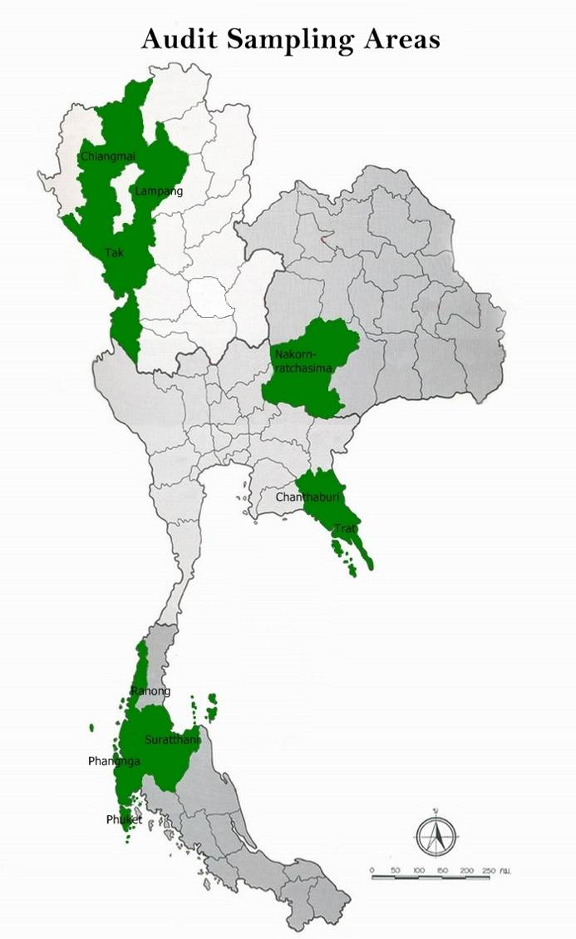 | - 21 Selected forest are Reserved Forest under RFD  - 35 Selected forest are Conservative Forest under DNP  - 11 Selected forest are Mangrove Forest under DMCR
  Region/  province | Number of Selected forest
  Northern | 24 forest
  Chiangmai | 8 forests
  Lampang | 8 forests
  Tak | 8 forests
  North-East | 6 forest
  Nakorn-ratchasima | 6 forests
  Eastern | 8 forest
  Chanthaburi | 4 forests
  Trat | 4 forests
  Southern | 29 forest
  Ranong | 7 forests
  Suratthani | 7 forests
  Phang-nga | 9 forests
  Phuket | 6 forests
  Total | 67 forest

- Interviews; In-depth interview were conducted with the executives, authorities, and officers, whose work concerned to the responsibility in forest demarcation and forest management from 3 forest agencies as the central office and group discussion interview at the regional office in order to collect the problem and recommendation of forest demarcation and forest management in Thailand. To interview the executives, authorities, and officers of other relevant agencies as shown in appendix 3 involved in forest demarcation, to collect the problem and recommendation of forest demarcation among agencies.
And interview the surrounding people who live in or nearby the forest in order to collect the problems and conflict between people and officers.
- Questionnaire; the questionnaire was designed by the audit team for the executives, authorities, and officers who participated in group discussion to know the condition and limitation in forest demarcation including recommendation.
- Observation; the observation was planned to collect the primary data of observed areas related to the position of boundaries, the condition of forest area, the condition of encroachment, the condition of boundary marking/sign, etc.

Table : The number of questionnaire and observation differentiate by type of form.
Type of form | RFD | DNP | DMCR | Total
Questionnaire
- Executives/Authorities | 12 | 18 | 3 | 33
- Officers | 15 | 31 | 8 | 54
- Surrounding people | 13 | 21 | 6 | 48
Observation | 21 | 35 | 11 | 67
- Experts; as the forest demarcation is very complicated issue. It requires experts and specialist who have experience in GPS, GIS and Remote sensing technology. However, the knowledge in this field in OAG was not yet sufficient, thus OAG hired 2 consultants to support the audit team.
- Analyzing audit results; the audit team has implemented as the following the process;
- Listing all discovered problems during audit
- Analyzing the relations of problems and their breaking down into Cause – Problem – Outcome and draft audit report

Forest Audit Finding
The objective of the national forest policy is to maintain the forest area at least 40% of the country area (204,800 sq.km. approximately) which is divided into 25% of the protective forest and 15% of the productive forest in order to increase rain absorption and to balance the demand of timber. Moreover, the national forest policy defines more than 35% of the area with slope is forest land which the issuance of deed or certification of utilization is prohibited in these area. Anyhow, the total forest area in Thailand was 172,185 sq.km. or 34% of the country in 2007.
Encroachment, which derives from economic growth, increased tourism, population growth, and agricultural price control, affects to the demand for cultivated land that is the main reason of deforestation.
The ambiguous forest demarcation is the main reason of conflict in land use between forest agencies and other relevant agencies, or between government agencies and surrounding people while the forest agencies still can not manage or solve this problem.
In Thailand, three agencies have responsibility for the forest management under MNRE. RFD is responsible for productive forest that is 1,221 Reserved Forests. For the protective forest, DNP is responsible for 123 National Parks, 58 Wildlife Sanctuaries, and 60 Non-Hunting Areas. DMCR is responsible for Mangrove Forest 1,270 polygons.
The audit in forest demarcation of RFD, DNP, and DMCR found that the forest demarcation has not been defined clearly and covered; the boundary markings were inefficiency and ineffectiveness; the forest demarcation is unacceptable of the surrounding people; and there were many Ground Control Points in the same area with different standards. The details are as follows:

Finding 1: The forest demarcation has not been defined clearly and covered.

The improvement process of the forest demarcation is shown as follows;
- First, transfer the old map as annexed law to Topography map scale 1:50,000 after that digitize and rectify the map with all data under the standard.
Data to rectify: old forest map annexed law, old coordinates of the forest boundary which was surveyed and posted the pillars by the forest officers, Topography map, Orthophoto map, the categories of land use in the forest and other data such as Field Book, etc.
- Second, making the Ground Control Point for ground check at real location.
- Third, survey and post the pillars along coordinates. The important thing of ground check is participation of other relevant government agencies and surrounding people.
- Fourth, adjust the boundary on map sheets after ground check at real location.
- Fifth, making the map sheet at scale 1:4,000 which shows the boundary line and the coordinates table of boundary.
- Lastly, gazette revised legislation in Royal Gazette with new map and the table of coordinate.
The audit found that all forest in Thailand consists of 1,221 Reserved Forest, 123 National Parks, 58 Wildlife Sanctuaries, 60 Non-Hunting Areas, and 1,270 Mangrove Forest. They have not clearly shown the forest boundary and the coordinate. Moreover, the forest demarcation did not cover all forest as shown in the sub audit finding.
  - The forest boundary rectification is varied by the officer’s discretion.

In the forest demarcation, the forest officer has to transfer the rough scale map as annexed law to larger scale map and specify the boundary coordinates to use in posting forest boundary markings. By transferring must use discretion in rectification the map. Therefore if the standard of rectification is not set, the forest boundary of each officer will be different.
The audit found that 19 from 32 sampled forests (exclude the conservative forest) had different rectified boundary in each forest
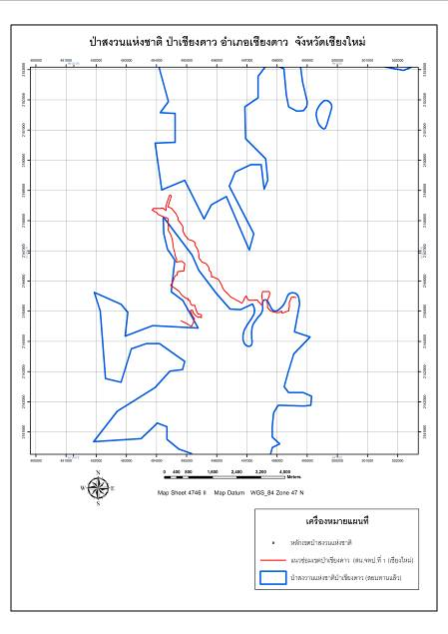
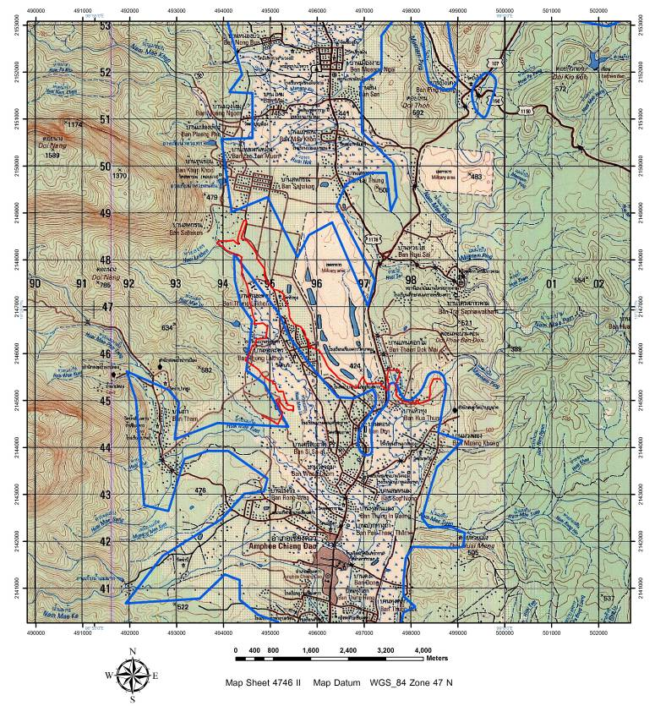
Figure 1-2: The different forest boundary caused by the rectification of different officer.
The red line is the rectified boundary by the officer of Forest Resource Management Office 1 (Chiangmai).
The blue line is the rectified boundary by the officer of consultancy firm which was hired by MNRE.
Place: Pha Chiang Dao (Reserved Forest), Chiang Mai Province.

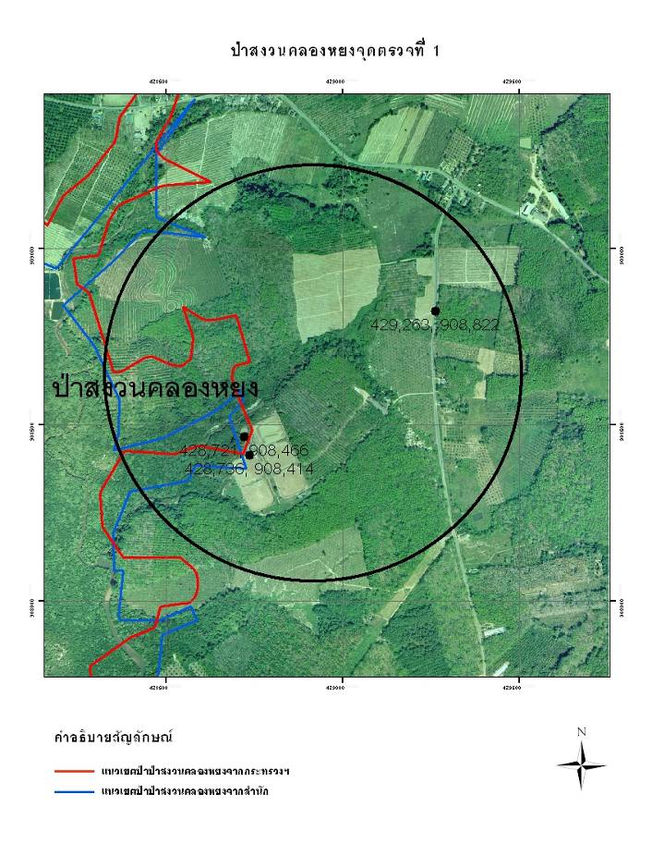
Figure 3: The different forest boundary caused by the rectification of different officer.
The red line is the rectified boundary by officer of consultancy firm which was hired by MNRE.
The blue line is the rectified boundary by officer of Forest Resource Management Office 12 Krabi Branch.
Place: Pha Klong Yhong (Reserved Forest), Phang-nag Province.
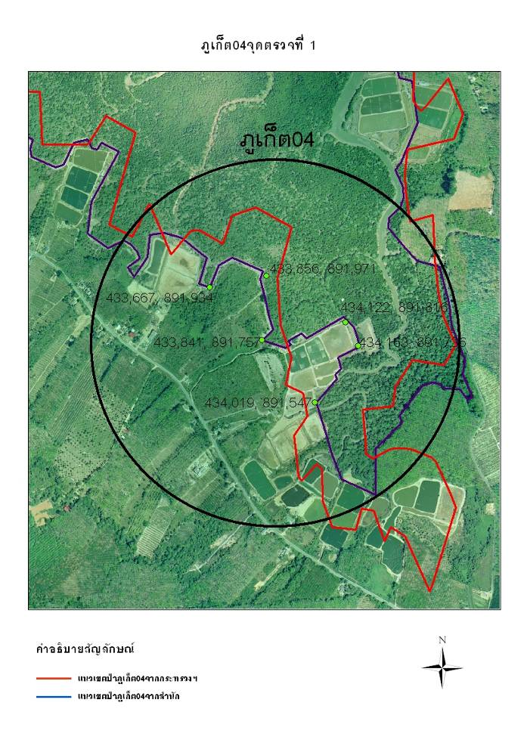
Figure 4: The different forest boundary caused by the rectification of different officer.
The red line is the rectified boundary by officer of consultancy firm which was hired by MNRE.
The blue line is the rectified boundary by officer of consultancy firm which was hired by DMCR.
Place: PK 04, Phuket Province.
The effect of different boundary makes confused and unclear forest management, including law enforcement with encroacher.
The different boundary rectified by different officer caused by the small scale of gazetted map, lack of coordinates, and changing of physical condition referred in gazetted map. Transfer the gazetted map from small scale to larger one caused many mistakes. For example, the gazetted map with scale 1:500,000, the thickness of boundary line is 1 mm. equals to 500 m. in actual location which some people had settled in this area. It is very difficult to definitely identify the position and prove the land tenure.
The data collecting from the sampled forests found that the gazetted map used various scales from 1:30,000 to 1:500,000 and its detail are as follows:
Table: The scale of map as annexed law.
Unit: Forest
Scales | Type of Forest |  |  |  | Total
Scales | Reserved Forest | National Park | Wildlife Sanctuary | Non-hunting Area | Total
1:30,000 | 1 | 0 | 0 | 1 | 2
1:40,000 | 2 | 0 | 0 | 0 | 2
1:50,000 | 1 | 1 | 0 | 1 | 3
1:60,000 | 0 | 1 | 0 | 0 | 1
1:80,000 | 2 | 0 | 0 | 0 | 2
1:100,000 | 3 | 4 | 0 | 0 | 7
1:150,000 | 0 | 1 | 1 | 0 | 2
1:160,000 | 2 | 0 | 0 | 0 | 2
1:200,000 | 7 | 9 | 2 | 0 | 18
1:250,000 | 2 | 4 | 2 | 0 | 8
1:300,000 | 0 | 1 | 0 | 0 | 1
1:400,000 | 1 | 0 | 0 | 1 | 2
1:500,000 | 0 | 1 | 0 | 0 | 1
Total | 21 | 22 | 5 | 3 | 51
Remark: The data of 5 National Parks did not known and 11 Mangrove Forests did not identified in gazetted map.
Therefore, the forest boundary will be differentiated, if the officers transfer the gazetted map to large scale map and rectify without the implementation standard. The rectification of officers depended on their knowledge and experience. Therefore, the rectified boundary by each officer will be different by their discretion. Moreover, methodology and standard which are used in transfer the gazetted map have difference under constraint of budgets, instruments, technologies, etc. For example, to compare with DNP, RFD there was many forests in their responsibility but few officers having knowledge and experience. The budget of RFD less than DNP thus DNP had new instruments which were more efficiency than RFD.
  - The forest boundary from the map annexed the law had differed from the boundary which the officer had protected.
In 2009, the Minister of Natural Resources and Environment had assigned DNP to explore the reserved forest area which its border was close to the National Park or Wildlife sanctuary. In case it was a fertile forest, DNP must append it to be National Park or Wildlife sanctuary.
The audit found that the forest boundary which was protected by officer differed from the forest boundary in the map as the annexed law. As some fertile forests, which are suitable for conservation, were not declared as the protective forest. Thus, they had protected these areas for being forest area. From 35 sampled conservative forests found that 22 forests or 62.86% of forest boundary were different between the boundary in gazetted map and the boundary which was protected. Nowadays those forests still were not declared as the protective forest.
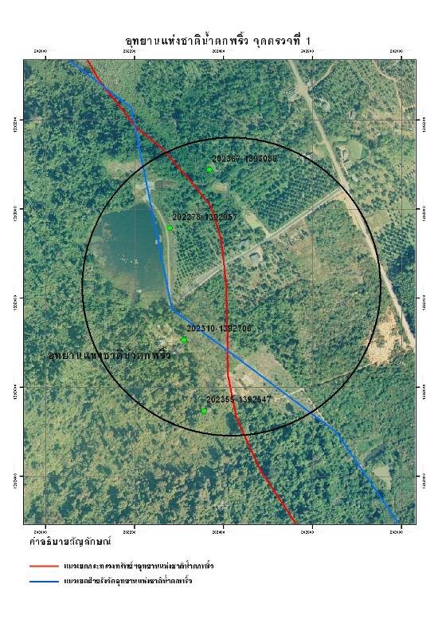
Figure 5: The forest boundary in gazetted map had differed from the forest boundary which the officer protected.
The red line is the boundary in gazetted map.
The blue line is the rectified boundary by DNP’s officer. By consider the protected area of local officer in rectification.
The left side of the red line is Namtok Phlew National Park. The red circle shows that the red line does not cover National Park Protection Unit 4 (Namtok Makok) while the blue line considering the protected area covers it.
Place: Namtok Phlew National Park, Chanthaburi Province.
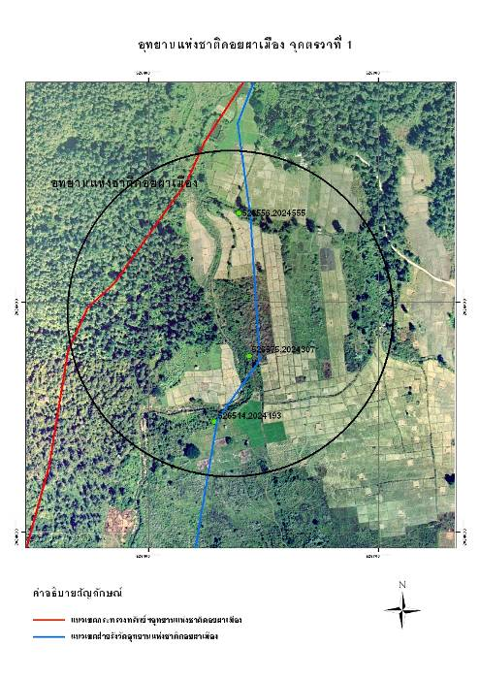
Figure 6: The forest boundary in gazetted map had differed from the forest boundary which the officer protected.
The red line is the boundary in gazetted map.
The blue line is the rectified boundary by DNP’s officer which was considered the protected area by local officer in rectification.
The left side of red line is Doi Pha Muang Wildlife Sanctuary which does not cover some fertile forest areas while the blue line covers it.
Place: Doi Pha Muang Wildlife Sanctuary, Lampang Province.
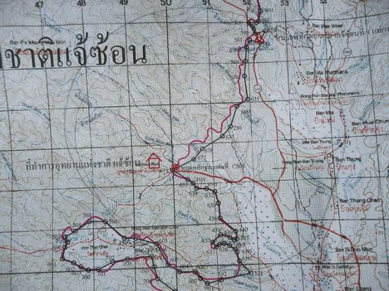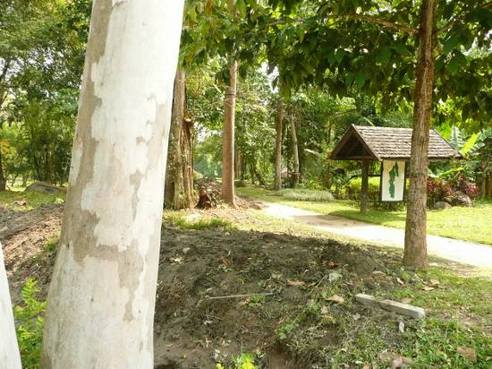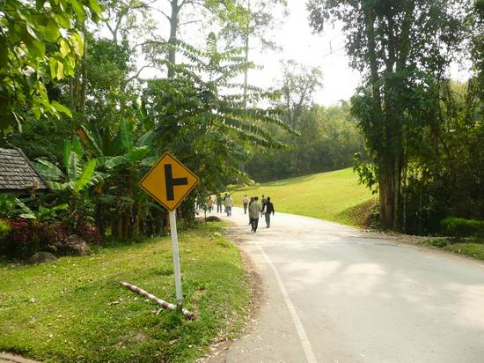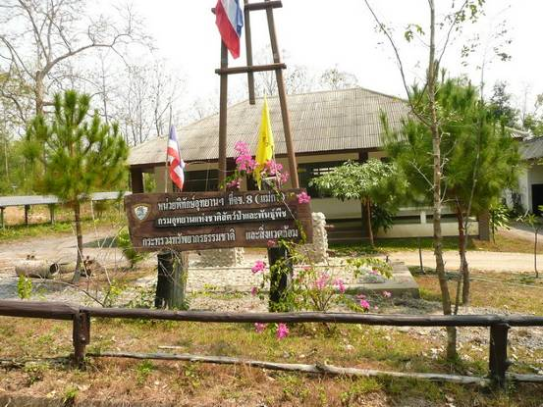
Figure 7-8: Left sides are hot spring zone and accommodations zone of Chae Son National Park. They are outside National Park, if they are considered from the gazetted map.
Figure 9: Top-right side is National Park Protection Unit 8 (Mae Ka). This area is outside National Park, if it is considered from the gazetted map.
Figure 10: Down-right side is some observation points at Chae Son National Park.
Place: Chae Son National Park, Lampang Province. Date: March 11, 2011

The effects of difference between the boundary in gazetted map and the boundary which was protected by officer were the budget allocation that was not appropriated to the responsibility area, confusion and unclear in forest management and law enforcement.
  - The forest boundary from the map annexed the law did not cover the watershed area.
The national forest policy defines that the slope area over 35% is forest land which the deed or certification of utilization issuance can not be done and they mostly are the vast source of conservation.
The audit found that the forest boundary in some cases lied on the slope area over 35% thus the forest boundary still did not cover the watershed area.
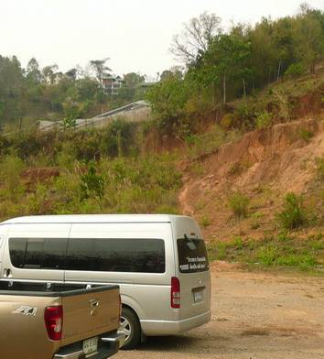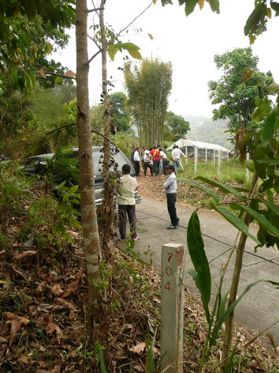
Figure 11-13: The left side presents the house in the slope area over 35% but the owner got deed on this land that is located in the source of watershed area.
The right side, behind the pillar is Doi Suthep-Pui National Park. The white tent is the cultivated area which is the slope area over 35%.
Place: Doi Suthep-Pui National Park, Chiang Mai Province. Date: March 9, 2011

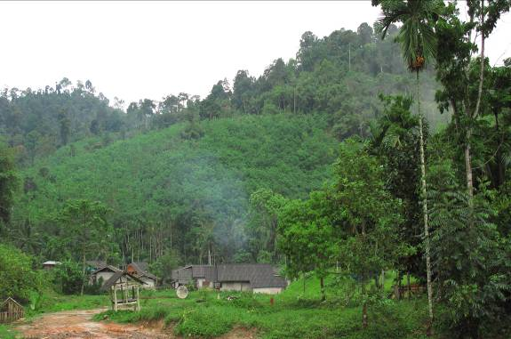
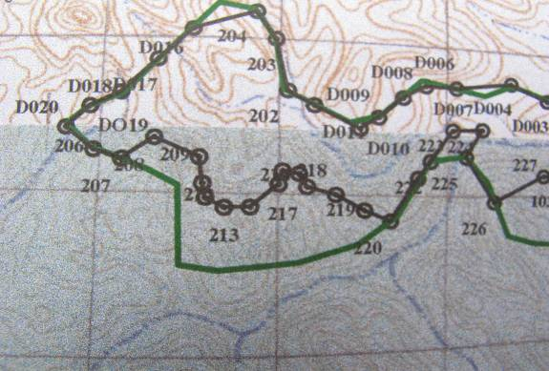
Figure 14-15: The forest boundary did not cover the watershed area.
The red ovals are outside Khlong Yun Wildlife Sanctuary but they are slope area over 35%, and they are the source of watershed area, which supposes to be forest land.
The red arrows point the forest area that its slope over 35% but it is outside Khlong Yun Wildlife Sanctuary. Nowadays, this area is rubber plantation.
Place: Khlong Yun Wildlife Sanctuary, Surat Thani Province.
Date: March 23, 2011

The effect of the forest boundary that does not cover the source of watershed area causes the lost of watershed area which is important to ecosystem and human living.
The causes of both the forest boundary from the map annexed the law had differed from the boundary which the officer had protected and the forest boundary in some areas did not cover the watershed area, are the gazetted maps of some forests were sketched on map without ground checking and no identify the coordinates. Therefore some areas having fertile and suitable for conservation are not gazetted to be the protective forest. And some areas have people living before are gazetted to be the forest area. As a result, those people have to become the encroachers.
  - The forest boundary from the map annexed the law overlapped other areas.
    - The forest boundary overlapped inhabited area.
The audit found that the forest boundary of 34 forests from 67 sampled forests or 50.75% had overlapped inhabited area or agricultural area as shown in appendix 8. Moreover, it was found that some people had settled in forest before it was declared as a forest. And only some people had the land deed or certification of utilization. Nowadays, the government is still unable to prove and approve the land tenure of these people, and to arrest or take action against the encroachers. These are the cause of conflict between the officers and surrounding people, including surrounding people will not get land certificate until process of land tenure proving finishes.
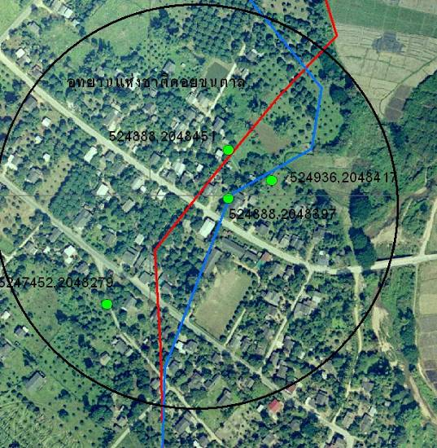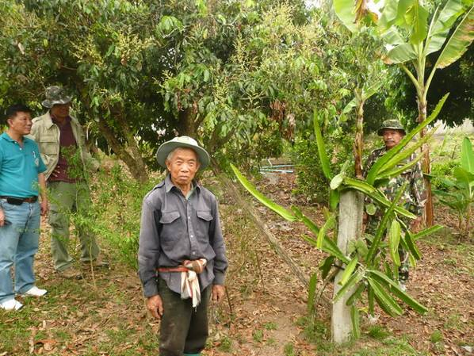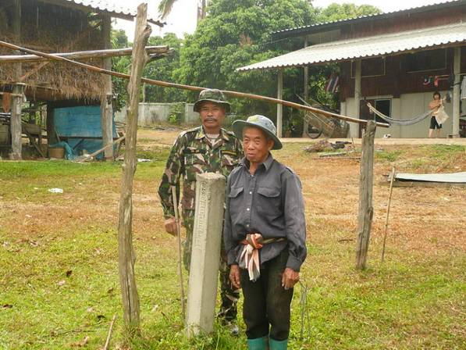
Figure 16-18: The forest boundary in gazetted map overlapped inhabited area.
The left side presents the observation point which is in Doi Khun Tan National Park.
The right side presents the pillar posted in inhabited area and agricultural area. Behind the pillar is Doi Khun Tan National Park.
By the top-right side presents dragon fruit tree planted on the pillar.
From interviewing the person in this picture, he informed that he had settled down in this area before it was declared as a National Park.
Place: Doi Khun Tan National Park, Lampang Province. Date: March 12, 2011

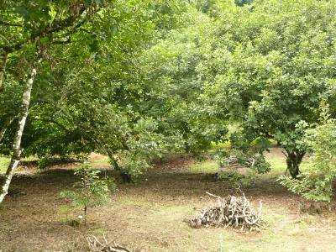
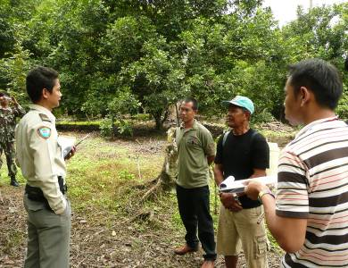
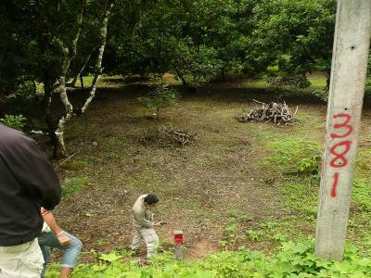
Figure 19-21: The forest boundary overlapped inhabited area.
Behind the pillar is Tai Rom Yen National Park where has rambutan plantation in this area. People claim the land right because they lived in this area before it was gazetted as a National Park. Nowadays they cannot cut stalk, branch or replant.
Place: Tai Rom Yen National Park, Surat Thani Province. Date: March 23, 2011

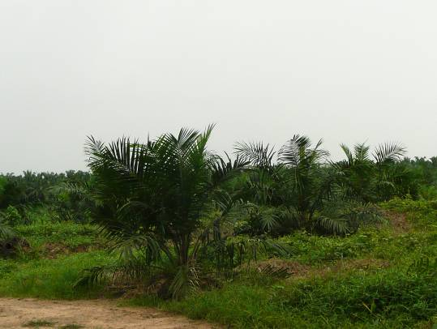
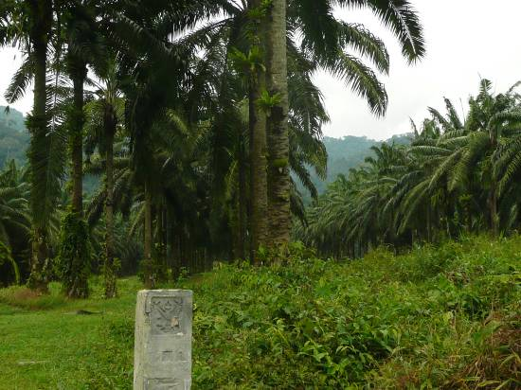
Figure 22-23: In past this area was Reserved Forest, private company had rented from RFD to palm plantation. Later it was declared as a Wildlife Sanctuary. Therefore, the private company was unable to replant any tree aged over 30 years.
In the figure, behind the pillar is Khlong Phraya Wildlife Sanctuary where is private company’s palm plantation.
Place: Khlong Phraya Wildlife Sanctuary, Surat Thani Province/Krabi Province.
Date: March 23, 2011

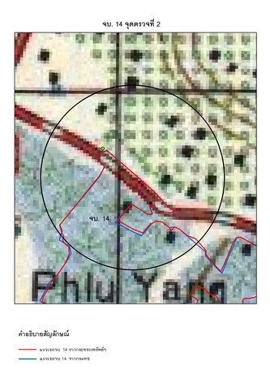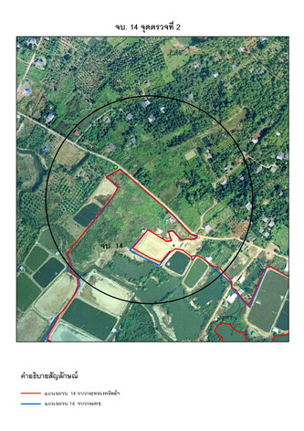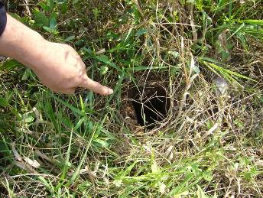
Figure 24-26: The area under the red line was declared as a mangrove forest. But surrounding people in this area claimed that they had settled down and had begun prawn farming before it was declared as such.
The right side presents the hole which surrounding people removed the pillar because they had settled down before the area had been declared as a mangrove forest.
Place: CHT14, Chanthaburi Province. Date: February 18, 2011

    - The forest boundary overlapped the responsible area of other agencies.
The audit found that forest boundary overlapped among forest agencies. For example, the forest boundary of Doi Suthep Non-Hunting Area overlapped both Doi Suthep-Pui National Park and Pha Doi Suthep (Reserved Forest). Moreover the forest boundary of Doi Suthep-Pui National Park overlapped Pha Doi Suthep (Reserved Forest) as shown in Figure 27.
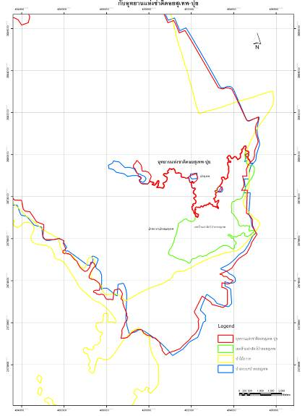
Figure 27: The forest boundary overlapped among forest agencies.
The red line is the boundary of Doi Suthep-Pui National Park.
The blue line is the boundary of Pha Doi Suthep (Reserved Forest).
And the green line is the boundary of Doi Suthep Non-Hunting Area.
Pha Doi Suthep (Reserved Forest) is under RFD whereas Doi Suthep-Pui National Park and Doi Suthep Non-Hunting Area are under DNP.
Place: Doi Suthep-Pui National Park, Pha Doi Suthep (Reserved Forest) and Doi Suthep Non-Hunting Area, Chiang Mai Province.
The forest boundary that overlapped among forest agencies affects the implement of officers. They are unable to arrest encroachers because the responsible area has not been defined clearly. As shown in Figure 28-29, during the observation in PNG04 and Pha Klong Yhong (Reserved Forest) found that mangrove trees in joint area, which was between private palm plantation and mangrove forest, were cut and replaced by palm plantation. Although the condition of this area was slush area and the mangrove trees were cut down, but DMCR's officers did not exactly know about their responsible area. Thus, they were unable to prosecute the encroachers. Finally RFD's officer took action.
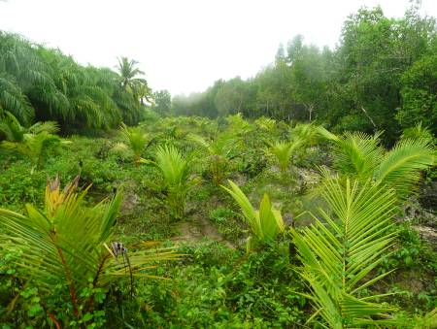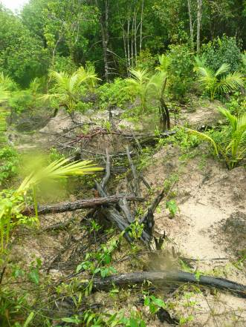
Figure 28-29: This area is Mangrove Forest. It is encroached for palm plantation.
The left side is palm plantation in Mangrove Forest.
The right side is mangrove trees which were cut down by encroacher.
Place: PNG04 and Pha Klong Yhong (Reserved Forest), Pang-nga Province.
Date: March 29, 2011
Besides, the state estate is under RFD, DNP, and DMCR responsibility. There are other relevant agencies which also have the state estate in responsibility namely The Treasury Department, Agricultural Land Reform Office, Department of Social Development and Welfare, and Cooperative Promotion Department. The audit found that forest boundary overlapped responsible area of other agencies in some forests.
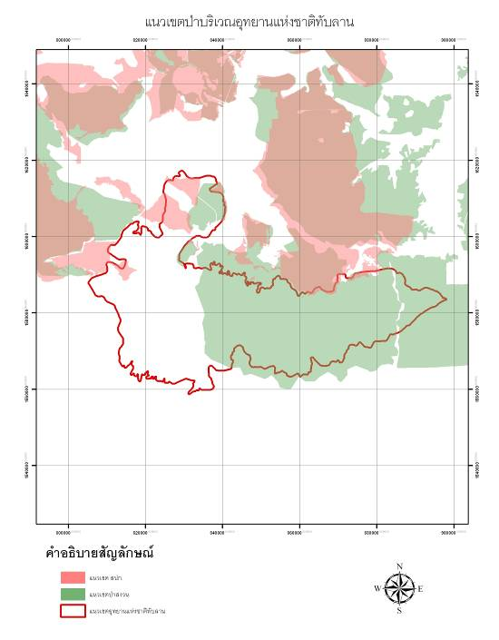
Figure 30: The forest boundary overlapped responsible area of 2 relevant agencies namely RFD and Agricultural Land Reform Office.
Place: Thap Lan National Park, Nakornratchasima Province.
During the interview of the executives and officer of other relevant agencies, they informed that nowadays their agencies still did not know their boundary areas exactly, causing of conflict in performance among government agencies.
The main cause of forest boundary overlapped inhabited area and other agencies, is the boundary line on the gazetted map was mostly sketched on map without ground checking. On the other hand, the lack of integration among agencies in demarcation is also cause of overlapping.
The effect of the forest demarcation has not been clearly defined and covered is the forest agencies have no information about actual responsible areas. Therefore, it is difficult to conserve or preserve forest areas and arrest encroachers, resulting in increasing encroachment. Moreover, some fertile forests and watershed areas have still not been gazetted as forest areas, causing loss of opportunity in increasing the forest area. For the forest areas, the forest agencies are necessary to have clear boundary line and specify the coordinates along the boundary line. Furthermore, the map annexed the law ought to show the coordinates point along the boundary line in order to increase efficiency and effectiveness of forest management.
It is apparent that the forest demarcation has not been clearly defined and covered which is above mentioned. The main cause is no the central agency responsible for land management of Thailand. Moreover, the agencies which have land in responsibility are controlled by different Ministry therefore causing the problems in commanding. And government policy in land management is unclear and no continuous. It is changed when there is a new government, and has no clear direction for managing with the overlapped areas and proceeding with the encroachers. Laws and regulations are inconsistent with current situation especially the map annexed the law which does not clearly show coordinates for forest boundary. Moreover, constraint of forest agencies are inadequacy of human resource, instrument and budget especially Royal Forest Department.
Recommendations for this audit finding are the government has to operate as follows:
1. Determine the policy, assign the main agency to clear the forest demarcation, command the relevant agencies to integrate the information and set the action plan in the same direction and standard.
2. Determine or declare the direction of proceeding against invaders and proceeding in overlapped areas by being fair with the surrounding people.
3. Determine the method for proving the land ownership and issuing the land tenure by proving the land tenure together with ground survey.
4. Review the target of forest area in the National Forest Policy, especially the protective forest, to be consistent with the actual condition.
5. Determine the main responsible agency to Thailand's land management and empower that agency to command and manage the relevant agencies.
6. Set up the committee or working group from the persons who have knowledge, ability and experience in forest demarcation to review and ground check the process of forest demarcation. Furthermore, in province areas, the provincial governor should participate in the forest demarcation and the boundary problem resolution.
7. Assign the forest agencies to integrate forest demarcation with regard to information, instruments and staffs.
8. Command the adjustment of the forest boundary and revise the forest boundary on map annexed the law.

Finding 2: The boundary markings were inefficiency.

Besides forest boundary must be gazetted in law together with map. Forest officer must sufficiently provide the boundary pillars and signs or other marks for public acknowledgement of the boundary of reserved forest and conservative forest.
From 67 sampled forests, 60 forests had get budget to post the boundary markings/signs before the budgetary year B.E. 2554 (2011). By 21 forests finished the boundary markings/signs all around the forest. And 39 forests still did not finish the boundary markings/signs all around forest. Remainder 7 forests had get budget in the budgetary year B.E. 2554 (2011) The audit found that the boundary markings were inefficiency and ineffectiveness. By the sub audit finding as follows;
  - The boundary markings did not sufficiently cover all around forest.
From observation found that the boundary markings which were posted all around 21 forests did not sufficiently cover, especially in risk area of encroachment such as the area close to inhabited areas, sharply bent point, etc. Therefore, there was some gap among boundary markings, which causes of encroachment.
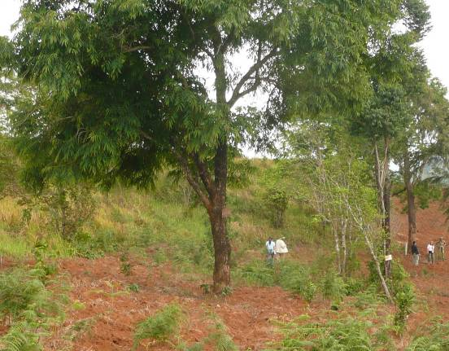
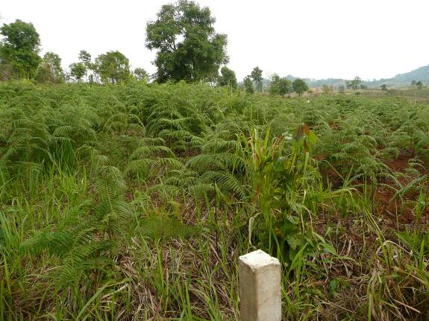

Figure 31-32: On the left side, red oval is tree which has boundary signs. The red line shows boundary which separates the forest land with private land. On the left of red line is forest land, whereas on the right is private land. In this picture, the macadamia plantation was cultivated by encroaching upon the forest.
On the right side shows the tree, which is marked the forest boundary, within the red oval of left picture.
Place: Lan Sang National Park, Tak Province. Date: March 16, 2011

This condition is consistent with the answer in questionnaire of executives and officers, amount 30 from 87 persons or 34.48% mention that the problem of forest demarcation is the pillars are posted too far apart. Moreover, the questionnaire of executives and officers amount 47 from 87 persons or 54.02% mention that the forest demarcation which does not cover risk areas is the main cause of encroachment as the surrounding people often claim that they did not know about the forest boundary.
  - The boundary markings were made several times within the same area or were posted near the road.
The observation found that the boundary markings amount 8 forests from 67 sampled forests or 11.94%, as shown in appendix 10, were posted in same area by both internal agency and other forest agencies, or were posted near the road which can be used as a substitute for the boundary marking.
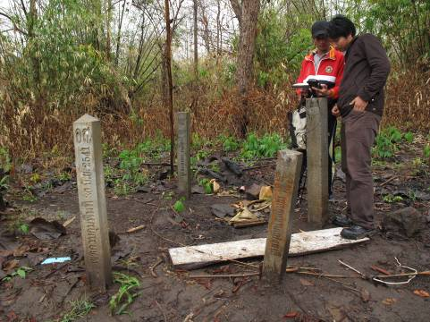
Figure 33: Too many of boundary markings were posted in same area. In this figure, all of 4 pillars were posted by DNP.
Place: Khlong Wang Chao National Park, Tak Province.
Date: March 17, 2011
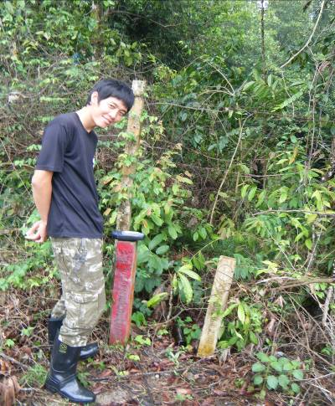
Figure 34: Too many of boundary markings were posted in same area. In this figure, 2 pillars were posted by DNP and DMCR in same area because of the overlapping area.
Place: Sirinat National Park and PK02, Phuket Province.
Date: April 1, 2011
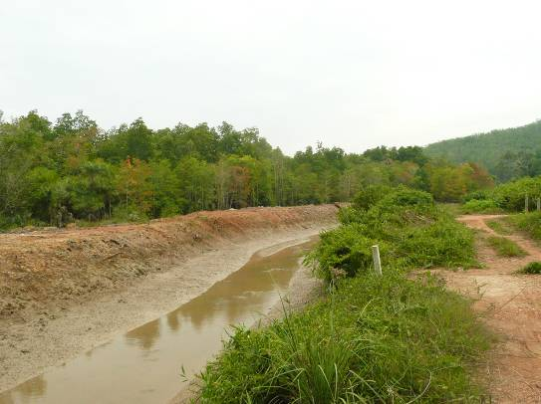
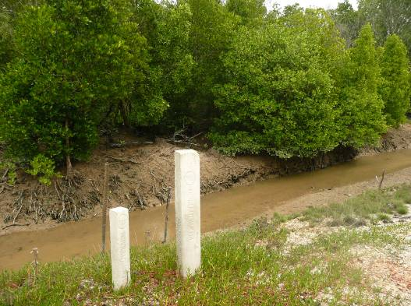
Figure 35-36: The left side presents the irrigation canal which was operated by Division of Mangrove Administration 2, after that DMCR hired a consulting firm to post the pillar in same area.
The right side presents the irrigation canal and the road which are the forest boundary. Therefore the pillar which was operated by DMCR is unnecessary.
Place: PK08, Phuket Province. Date: April 1, 2011

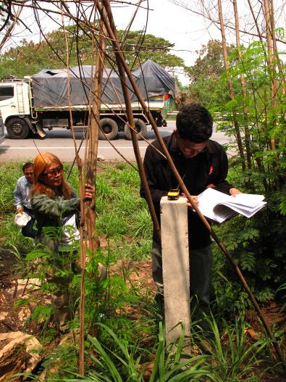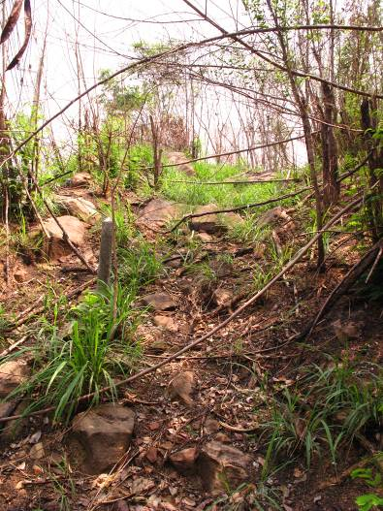
Figure 37-40: Pillars which were posted on roadside is excessive because the road can be used as the forest boundary.
Place: Pha Khao Tiean & Pha Khao Khun Lun (Reserved Forest), Nakhon Ratchasima Province.
Date: April 20, 2011
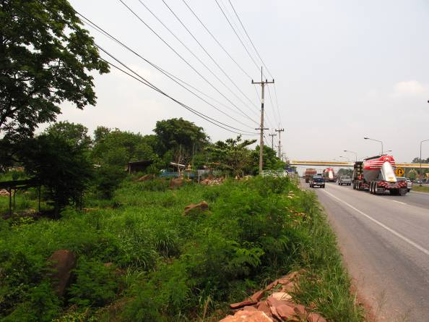
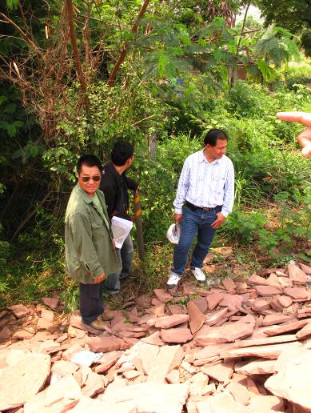

The effects of boundary markings were made several times in same area or were posted near the road which can be used as a substitute for the boundary marking are worthless budget and opportunity loss in using budget. And people are confused with forest boundary position. Its causes are both internal and external forest agencies does not integrate database concerning forest boundary markings, and forest boundary has overlapped among forest agencies.
  - The boundary markings which could not post were not reported.
The audit found that 14 forests from 67 sampled forests or 20.90%, as shown in appendix 11, could not post the boundary markings in some areas. Moreover, the officers did not report this problem and the number of pillars which could not be posted as the boundary markings. This may lead to the risk of fraud. The lack of good internal control system and follow-up the boundary markings are the causes of this case.

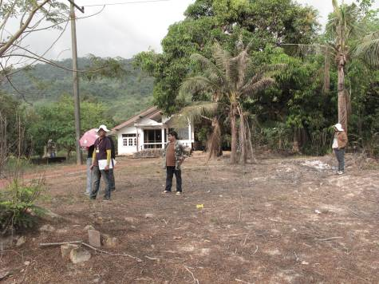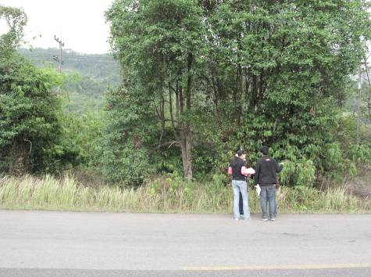
Figure 41-42: The forest area which the officer could not post the pillar and did not report the problem.
Place: Pha Thueak Khao Banthat (Reserved Forest), Trat Province.
Date: February 19, 2011

Moreover, during the observation at Lan Sang National Park found that the coordinates in report was incorrect. That is the coordinates of the pillar no.104 corresponds to the coordinates of the pillar no.105 in report. And the coordinates of the pillar no.105 corresponds to the coordinates of the pillar no.106 in report.
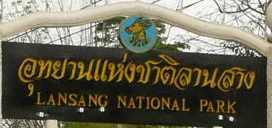
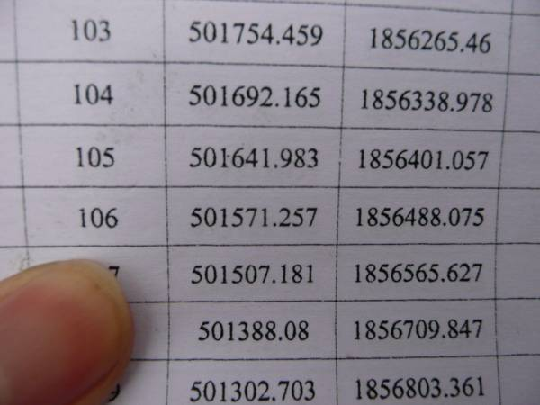
Figure 43-44: Measurement found that the coordinates of the pillar no.104 was 501619E, 1856367N which was the coordinates of the pillar no.105 in report. The coordinates of the pillar no.105 was 501563E, 1856454N which was the coordinates of the pillar no.106 in report. Thus the coordinates of all next pillars were incorrect.
Place: Lan Sang National Park, Tak Province.
Date: March 16, 2011

Recommendations for this audit finding are forest agencies have to emphasize setting up the boundary markings at sharply bent point and the area having the risk of encroachment, clear forest boundary to eliminate overlapping problem, integrate information of forest demarcation, set the internal control system, and verify the accuracy and transparency of the boundary marking activity.

Finding 3: The forest demarcation is unacceptable of the surrounding people.

The objective of the forest demarcation is to announcement the forest boundary for the recognition of the surrounding people, and to protect the forest land from encroachment or illegal use of land.
From interview the surrounding people living in 40 sampled forests found that the surrounding people from 15 forests or 37.50% did not accept the forest boundary, whereas the surrounding people from 25 forests or 62.50% have still lived in forest area although they accepted the boundary. Furthermore, the surrounding people from 12 forests or 30.00% did not participate in forest demarcation but the community leaders had often participated.
The forest demarcation is not sufficient in solution of encroachment. Because the boundary marking/sign will be worthless if the surrounding people does not accept it.
From observation of 67 sampled forests found that the boundary markings in 13 forests or 19.40% were pulled down beside the holes by the surrounding people. These people claimed that they had settled down and had cultivated in the area before it was gazetted as a forest. Some people have deed or land certification as the evidence of their property rights in the area. In the case that the boundary markings were posted in agricultural areas, they would be pulled down as the obstruction in cultivation. It also found that the boundary markings in 6 forests or 8.96%, as shown in appendix 14, were removed from one place to another because the surrounding people did not accept the forest boundary. Therefore, they moved them by themselves or by asking the officers to do such moving.

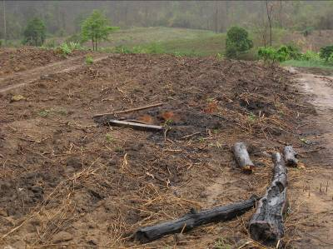
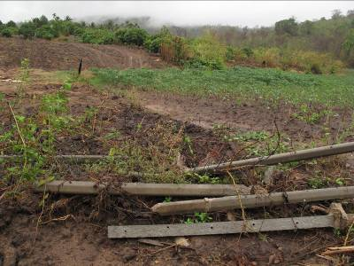
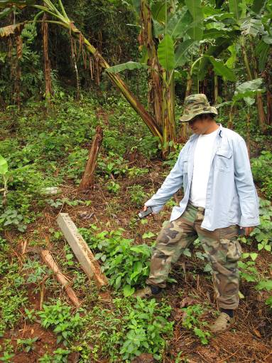
Figure 45-47: The left side and on the top-right, the pillar was pulled down by surrounding people. At the bottom-right, the fence operated by Protected Areas Regional Office 14 (Tak) was pulled down by the surrounding people who claimed that they had cultivated in this area before it was gazetted as a National Park.
Place: Khlong Wang Chao National Park, Tak Province.
Date: March 17, 2011

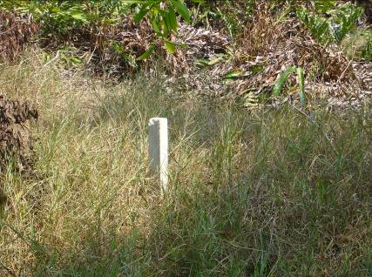
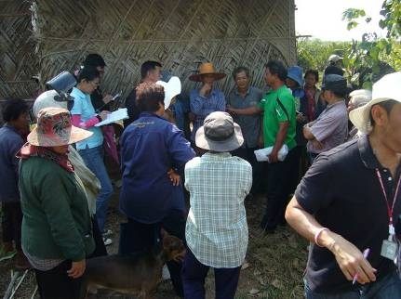
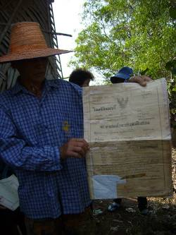

Figure 48-50: The left side is the pillar which was post in the inhabited area where the surrounding people have had deed since 1932. These surrounding people did not participate in forest demarcation, thus they do not accept forest boundary.
Place: CHT 14, Chanthaburi Province Date: February 18, 2011

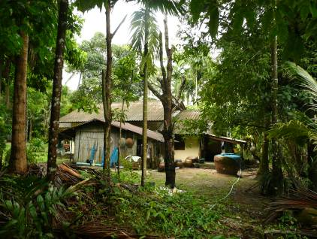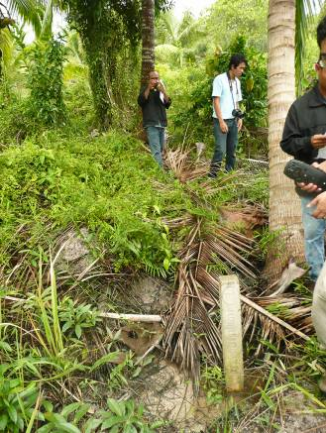
Figure 51-52: The left side is a house where the pillar should be posted in this area. But the people asked the officer to move it to the new position inside the mangrove forest as shown in the right side.
Place: RN 04, Ranong Province.
Date: March 25, 2011

The effects of unacceptable in forest boundary are conflict between the forest agencies and surrounding people, no cooperation in forest preservation, and loss in budget.

The causes of unacceptable in forest boundary are the forest agencies did not provide public relations information to make the surrounding people understand the objective of forest demarcation. Moreover, the forest agencies did not encourage the surrounding people to participate in forest demarcation. Also, the forest boundary line in some forests was sketched on a map without ground checking, causing overlapping between the forest area and the inhabited area.
Recommendations for this audit finding are the forest agencies have to focus on the public relations with the surrounding people to make understanding and acceptance in the forest boundary. Moreover, the public participation is an important process which will make the surrounding people recognizes the objective of the boundary markings and cooperates with the forest agencies to protect the forest.

Finding 4: There were many Ground Control Points in the same area with different standards.

The Ground Control Points (GCPs) is an important baseline data of Remote Sensing Image correction. The quantity, distribution and accuracy of GCPs play an important role in correcting Remote Sensing Image, ground checking and coordinates of forest boundary.
GCPs are the selected point used as the base of mapping and used for ground survey. GCPs are divided into:
- Main GCPs - the ground control point having highest quality.
- Sub GCPs - the ground control point having lower quality.
Royal Thai Survey Department is the only agency in Thailand which sets up main GCPs to use and the government agencies having the state land in their responsibility set up sub GCPs to use in ground survey. Anyhow some state lands have overlapped among agencies. During an interview of relevant agency’s officers, they informed that GCPs of each agency can be used together in ground survey.
Royal Thai Survey Department is responsible for land survey and aerial survey to make and produce the map used for public security and country development. Since surveying and setting up GCPs in 1991, Royal Thai Survey Department has set up 18 points of Main GCPs and 674 points of Sub GCPs.
In the year 2000, Land Development Department had operated the mapping project for environmental management. In this project, GCPs had been set up to expand control points on photo map used to rectify the ortho-photo mapping and used for the ground survey. Total budgets of this project were 1,465 million baht. The target of setting up GCPs was 2,800 points nationwide with GCP coordinates table. Setting up GCPs in this project was linked to Main GCPs Network of Royal Thai Survey Department.
The Department of Land is responsible for issuing the land right, right registration, and legal services relating to land and other properties. Therefore, GCPs were set up to be control point on photo map and used in ground survey. In 2008, the Department of Land had set up 1,429,689 points of GCPs nationwide.
Moreover, the other government agencies have set up GCPs such as Royal Irrigation Department, Agricultural Land Reform Office, Department of Public Works and Town & Country Planning, and Department of Highways.
In the past, the problem of forest demarcation is unacceptable in forest boundary among relevant agencies because of the different standard of survey and mapping. Therefore, Standard of map sheets and land use map in the state estate B.E. 2550 (2007) was used as the standard of making map sheets and ground survey of government agencies.
Beside the above-mentioned agencies, forest agencies under MNRE setting up GCPs are DNP and the Office of the Permanent Secretary of MNRE. DNP has set up GCPs one point in each forest under its responsibility, totaling 241 forests. Nowadays they have already set up 192 points or 79.67% of all conservative forests. And the Office of the Permanent Secretary of MNRE has set up GCPs 2 points in each forest, totaling 2,896 points. Hence, each conservative forest will have at least 3 GCPs excluding GCPs which were set up in the past.
By observation, it was found that 15 forests from 67 sampled forests or 22.39% (as shown in appendix 15) have many GCPs in the same area.
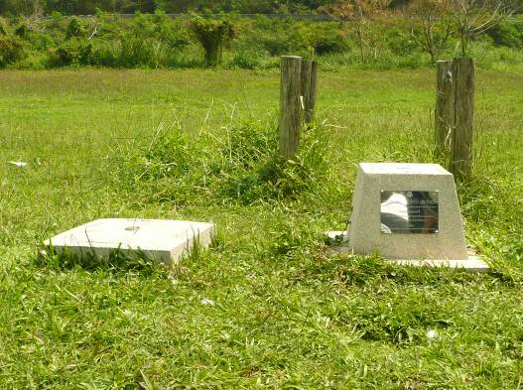
Figure 53: The left side is GCP of MNRE and the right side is GCP of DNP. They were set up in the same area.
Place: Doi Pha Muang Wildlife Sanctuary, Lampang Province.
Date: March 12, 2011

During an interview of the relevant officers, they informed that the cause of having many GCPs in the same area is that it is difficult to get GCPs information from other agencies. Another cause is the lack of integrated GCPs information. Thus, each agency has set up GCP of its own. The effect of having many GCPs in the same area is that the budget was spent inefficiently and abundantly.
Recommendations for this finding are the government has to command to revise the available GCPs to be on the same standard and revise the coordinates of GCPs for accuracy and reliability. Moreover, the government has to assign the main responsible agency to integrate all GCPs data of Thailand and allow other agencies to take GCPs data for using in operation and planning in order to eliminate redundancy in setting up new GCPs.

