Audit on air quality improvement measure of Seoul metro city area
SAI Korea

Background
Air pollution problem around the Seoul metro city area has been decreased since 1960s. Until 1980s, sulfur dioxide gas due to the combustion of coal and solid fuel was the major problems in Seoul. However, after the fuel constituent regulation (requirement of low sulfur fuel usage like gasoline, LNG, LPG) in late 1980s sulfur dioxide concentration in the air had been decreased. But, micro-particulates (PM₁₀ and PM_{2.5}) and nitrogen oxide has been increased due to the increase of cars and coal combustion power plants. Therefore the Korean government established a special law on Seoul metro city air quality control (Seoul, Incheon, Kyunggi), and setup an action plan for improving air quality every 10 years since 2005. By 2014, the government invested more than 3 billion USD for improving air quality. However, as on the figure, the improvement goal was not reached. Therefore, it is necessary to analyze the reason of the exceeding air quality improvement goal and amend the 2nd stage action plan from 2015 to 2024.
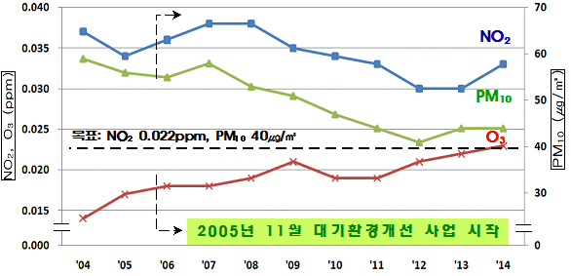
Fig. Air quality trend in Seoul
Importance of the topic
The topic was involved citizens and businesses because air quality was directly related with their living and the government action plan affects economic benefit by the government investment for technology and regulations. Also the topic was so challengeable due to the uncertainty of air pollution sources and the correct relation between the amount of air pollutant emission and the concentration of the pollutant in the air. First of all, the topic is a policy direction on air quality improvement measure for a long period (10 years), which means that all the uncertainties of the social, economic, and scientific status can make the audit more difficult and the ministries (i.e., Ministry of Environment) can argue with the audit result. However if we can provide objective and sound measures for air quality, long term policy can be changed and it can affect much part of the country including technology development and economic structures.
Audit Period: Oct. 2015 ~ Dec. 2015
Methodology
In order to conduct the audit, BAI established an audit support panel groups. The group was consisted of air quality management policy, chemistry, meteorology, modeling, pollution measurement experts, etc. The panel reviewed and supported audit recommendations and scientific data analysis. BAI also asked the ministry of environment to invest large factories which can emit air pollutants in order to derive an improvement measures to reduce air pollutant emission from the businesses.

BAI tried to provide scientific evidences and check up the accountability of the action plan by conducting 1) air quality modeling supported by scientists with various pollution emission sources and emission control scenario, 2) air quality monitoring data analysis and field sampling analysis, and 3) document examination for assuring the adequacy of the action plan and its evaluation.
Audit Findings, Recommendations and their Implementation:
Air pollution was not followed by the legal administrative area, but diffused by wind and controlled by the natural geographical feature. However, the action plan was only for the Seoul metro city. Based on the modeling by the audit panel group, the coal combustion power plants near Seoul, which was not controlled by the emission reduction plan on the action plan has affected the air quality of Seoul. It means that the action plan must be amended based on the influence area by the pollution sources.
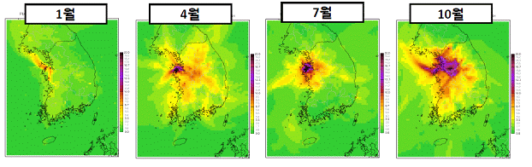
Fig. The diffusion of air pollutants from the large coal combustion power plants outside of the action plan target area

Also, we found that the efficiency of the air pollution reduction measures, i.e., diesel particulate filter (DPF) attachment support program. The program was the most largest financial investment program of the action plan (more than 90% of 3 billion USD for 10 years (2005-2014)). As it is seen on the figure, last 10 years, more than 300,000 diesel fueled cars had been refurbished by attaching DPF. However, it is seen on the figure, compared to the early stage of the program, the cars which does not emit much amount of particulate pollutants had been supported by the program in recent years. This means that the efficiency of the program has been decreased. Moreover, DPF only can reduce particulates, but recent PM_{2.5} or Ozone pollution in Seoul is caused by nitrogen oxides. This means that the action plan is not very much effective for recent air pollution trend. But the support program can affect so many car refurbish businesses. Therefore, BAI let Ministry of Environment hear from the businesses to reduce air pollution from the diesel car and provide the amendment methodology of the action plan.
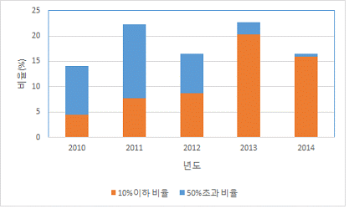
Fig. The trend of DPF attachment support program efficiency

Now, the Ministry of Environment discussed with all other stakeholders including local government, businesses and citizens to amend the action plan.

