Republic of Iraq
Federal Board of Supreme Audit

Federal Board of Supreme Audit's Role in Auditing the State Policy of Solid Waste
Management

A work paper Submitted to the Working Group of Environmental Auditing (WEGA) on Environmental Audit (ASOSAI) for the period 17-19 October, Jaipur - India

- Background:

Federal Board of Supreme Audit (FBSA) conducts audit through programs based on standard guidelines related to the solid waste management audit. The Board also evaluates the institutions' performance responsible for solid waste in terms of their commitment to laws, regulations and instructions issued in this regard.

We list below the most important applicable legislations and standards:

- Environmental Legislations issued by the Office of Protection and Improvement the Environment of 1988.
- Ministry of Environment Law No. (37) of 2008.
- Environment Protection and Improvement Law No. 27 of 2009
- Instructions of the Environmental Determinants to establish projects and monitor the safety of their implementation No. 3 of 2011
- Determinants of the World Health Organization)WHO) concerning (soil, air, water).

Reasons for Choosing this Topic:

Solid waste management is one of the important topics because of its direct impact on human health, in particular, and on the surrounding public appearance in general, as well as evaluating the utilization of this process to generate power or obtain the resources by recycling the waste.

Audit Objectives

The fundamental objectives of performance evaluation related to the state policy in the solid waste management which includes collecting, transporting, removing and dumping the solid waste and set up transfer stations and locations of the sanitary dumping are:

1- Evaluating the procedures taken by these institutions represented by safe disposal of municipal waste by collecting, removing and dumping such waste.

2-Illustrating the extent of awareness to the importance of introduction environmental management systems for solid waste management in the framework of laws organized the environment (polices adopted in the institution).

3- Illustrating the environmental impact on solid waste management and its effect on the industrial development projects.

- Audit Methods

1. Examining the commitment procedures to apply the related laws, regulations and instructions

- Examining the internal control system and evaluating it
- Financial compensation and fines for environmental offenses
- Evaluating the environmental projects
- Environmental Audit by using laboratory technical examination

- Audit Results:

The work team formed has evaluated the state policy program's performance of solid waste management. The evaluation included the offices below:

1- The Mayoralty of Baghdad and its offices responsible for this policy

The Mayoralty of Baghdad conducts by its municipal offices amounted (14) and the Office of Solid Waste and Environment all the activities concerning the solid waste which include removing, transporting and dumping by the self efforts of Mayoralty, hiring workers and private cleaning companies. By analyzing these risks and negative phenomena according to their importance related to the main problem described in the table below, it became clear (a weakness of the measures taken by the Mayoralty of Baghdad in the safe disposal of solid waste) to be as a priority in the evaluation process which considers the greater impact.
Risks Matrix

The Main problem | undesired Events and attitudes | The Probability | The impact | The Estimated risk | Range of risk | The response | The Remaining risk | The priority
Baghdad municipality's policy in collecting, transporting, removing and dumping solid waste and set up transfer stations and sanitary dumping sites | weakness of the measures taken by the Mayoralty of Baghdad in the safe disposal of solid waste | 9 | 9 | 81 | 45 | operational | 36 | 1
 | Lack of financial allocations in the provision of effort needed to process waste management | 9 | 8 | 72 | 40 | operational | 32 | 2
 | a weakness of the Ministry of Environment’ role in controlling the process of waste management | 8 | 8 | 64 | 35 | operational | 29 | 3
 | There is no clear plan for sorting operations from the source and benefit from the outputs of sorting operations | 7 | 6 | 42 | 15 | operational | 27 | 4
 | No benefit from the waste in the process of energy production | 5 | 5 | 25 | 0 | operational | 25 | 5

The Matrix and Risks Identification

By using the risk matrix to determine the priorities of the risks during the implementation process, the subject " a weakness of the measures taken by the Mayoralty of Baghdad in the safe disposal of solid waste" has been selected due to the probability of its impact on the performance of municipal offices, solid waste offices and environment which are affiliated to the Mayoralty of Baghdad in regards to solid waste management.
Sub-risks Matrix

The secondary problem | undesired Events and attitudes | The Probability | The impact | The Estimated risk | Range of risk | The response | The Remaining risk | The priority
A weakness of the measures taken by the Mayoralty of Baghdad in the safe disposal of solid waste | Lack of appropriate dumping sites | 9 | 9 | 81 | 15 | operational | 66 | 1
 | lack of citizen awareness in the environment | 9 | 8 | 81 | 40 | performance | 41 | 2
 | the cleaning effort is not convenient with the amount of waste due to lack of financial allocations | 9 | 7 | 63 | 35 | operational | 28 | 3
 | Lack of plants for sorting and recycling of waste and use of modern means for safe disposal of waste | 6 | 8 | 48 | 28 | operational | 20 | 4
 | Lack of municipal offices’ commitment to dump waste in the designated dumping sites by the Solid Waste and Environment Office | 6 | 6 | 36 | 18 | operational | 18 | 5

The Federal Board of Supreme Audit (FBSA) team collected the information from the offices, departments and divisions and it reached to the following conclusions:

- Audit Mechanism for Implementing the Environmental Policy

The right strategy of safe solid waste management is represented by the way of cleaning departments in the municipal offices conduct their business in collection, transporting and dumping the solid waste according to the environmental determinants and the mechanism to treat the municipal waste and get benefits in energy production and recycling, as well as the establishment of appropriate dumping sites according to the environmental determinants and conditions for establishing these sites to ensure the safe waste management, protect the surrounding environment from pollution and ensure that no diseases resulting from the accumulation of waste will be spread. We have reached these matters by studying the state’s policy in collecting, transporting and dumping the solid waste and establishment of the transfer stations and sanitary dumping sites according to the applicable criteria and indicators in this field in addition to the data and information submitted by the related bodies. Below, we list the most important conclusions and recommendations that we have reached in this regard:

- Audit Conclusions :

By studying the initial documents submitted by the related offices and the field visits to the sites, the following points have been shown:

- The automated and human efforts on the collecting and transporting waste are not appropriate with the amount of waste produced within the geographical area in which the municipality is responsible.

- The control on the movement of garbage vehicles involved in the clean-up is weak. This negatively affects on transporting the waste properly despite the fact that some offices installed GPS, but it was not applied correctly.

- Lack of citizens awareness to the issue of waste treatment and sorting them from the source and encroaching upon the containers placed in the streets as well as throwing randomly the waste in places unallocated (median strips and pavements) which makes difficult to collect and transport the waste in addition to the lack of awareness campaigns to the citizens by municipal offices.

- Lack of central following- up by the related offices concerning the workers’ occupational safety in the cleaning fields in terms of providing the occupation safety equipments to the workers and conducting the periodic tests.

- There are inappropriate places to collect waste in the form of landfills which are close to the residential neighborhoods and main streets in the municipal offices. This negatively affects on the surrounding environment as well as the specialized departments do not conduct acts of combat rodents and insects to those stations.

- Some municipal offices do not have appropriate transfer stations

- There are mistakes in the designing of the appropriate transfer stations (the pressers) and lack of processing units for leachate (liquid waste) from where it has been discharged into the sewage networks directly without any treatment and finally received without addressing those mistakes.

- The related offices do not depend on modern scientific methods in safe disposal of waste and not make any treatments of waste despite they contain materials with slow decomposition which affect on the surrounding environment as a result of their accumulation and not decompose for long times.

- Delay in completing the project of establishment two plants for sorting waste in Baghdad despite the end of the contractual period to build the project that its achievement ratio reached %77.4.

- Lack of an appropriate dumping sites based on sound scientific methods in the dumping according to the environmental determinants to establish projects and monitor the regulations of implementation safety no.(3) of 2011 Article (24).

- Spread of waste into dumping sites randomly without following the sound methods to dump them in addition to the burning waste phenomenon inside the dumping sites which leads to air pollution with toxic gases and carcinogens especially )dioxins(.

- Most municipal offices dump the waste in sites not intended for dumping by the related offices.

- The closed dumping sites are not utilized after ending its operational life and make it green areas or garages according to the instructions in this regard. This has led to use these sites again by some municipal offices to be randomly as dumping areas.

- The appropriate sanitary dumping areas are not utilized (such as al-buaiatha in Baghdad) which contain underlying cells to ensure no leak of leachate.

- No appropriate dumping sites were established in some areas despite they had been listed in the regional development plan since 2010 due to lack of appropriate allocation of area in spite of the continuing correspondences by the authorities concerned.

- Audit Recommendations

- Providing the financial allocations required for collecting and transporting the waste by providing automated and human efforts.

- Activating (GPS) system correctly and centrally as well as including all municipalities and garbage vehicles without exception.

- Increasing the citizens’ awareness campaigns to raise the environmental awareness and introduce them the safe waste management and activating the fines for violators.

- Providing the occupational safety requirements for workers in the cleaning field, followed up them on a continuous basis obliging them to wear these requirements and conducting a regular check-up.

- Forming investigative committees to find out the reasons for not addressing the design mistakes in the appropriate transfer stations (pressers) and not establishing units for processing the leachate(liquid waste) resulting from the work of those stations.

- Establishing a specialized department for maintenance of appropriate transfer stations (pressers) and provision of spare parts.

- Introducing modern scientific methods to treat municipal waste and speed up the completion of establishment sorting and recycling plants.

- Establishing appropriate dumping sites rely on scientific methods such as underlying cells to ensure the safe waste dumping, reducing the phenomenon of burning waste and spreading wildly into dumping sites and speed up the completion of the appropriate dumping sites in Al-Rusafa (Al-nahrawan).

- Accounting the violators from municipal offices on the dumping sites identified by the relevant departments which dump waste in random places without any control.

- Establishing parks or garages in dumping sites after the end of their operational life, according to the environmental determinants in this regard to ensure that these places will not be used again as landfills of waste.

- Speeding up the completion of appropriate sanitary dumping rehabilitation and forming a committee to find out the reasons of low project achievement ratios.

- Speeding up the completion of the environmental projects included in the 2015 plan, as well as approving the environmental projects mentioned in 2016 plan being one of the important projects to preserve the environment.

2- Ministry of Municipalities and Public Works

(14) Provinces are affiliated to the directorate general .These municipalities’ directories in the provinces are classified into two types:

- The Municipalities of excellent class which are responsible for waste management in the provinces centers.

- The municipalities of the excellent first, second and third class which are responsible for waste management in the centers of districts, counties and towns.

Financing of these municipalities is made by two ways:
- A grant from the government
- Self-revenues

By the Federal Board of Supreme audit’s work teams to audit work mechanism of the municipalities directorates, the following observations have been raised:

First: Most dumping sites did not obtain the environmental approvals because they do not meet the environmental determinants. The number of sites obtaining environmental approvals is (55) and non-obtaining environmental approvals (137) out of the total amount of dumping sites amounted (192) all over Iraq except Kurdistan region.

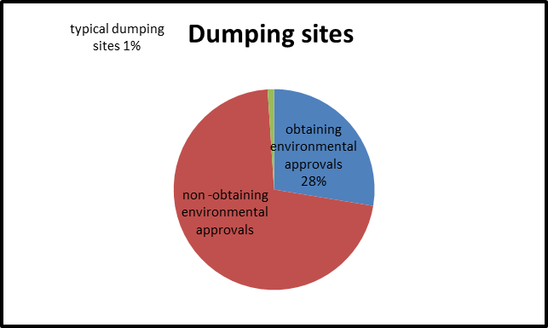

Second: The number of transfer stations in all Iraqi provinces except Kurdistan region amounted (81), but the number of stations obtained the environmental approvals reached to (12) while the remaining transfer stations (69) not obtained environmental approvals for non-compliance to the environmental determinants.

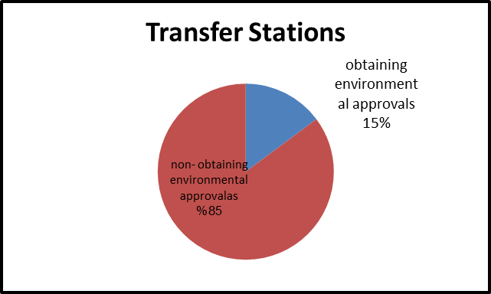

Third: The high proportion of specialized operative garbage vehicles number (presser, sweeper streets, bulldozers, tractor, tipper, dumpster carrier, waste roller) reached to 18% out of the total vehicles proportion in some provinces (28%) as in the holy city of Karbala, which negatively affects on the service provided. The following chart illustrates the percentages for each province excluding Kurdistan region.

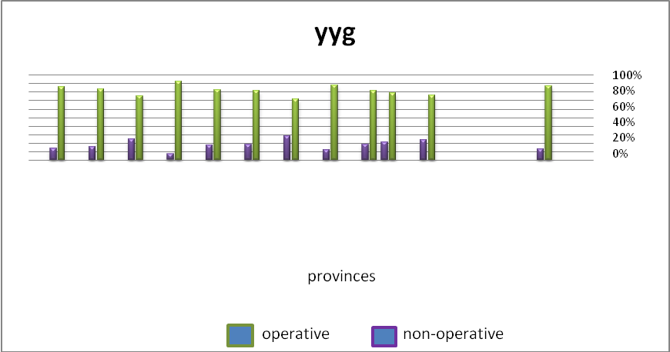
Operative and non-operative machineries for Iraq (2014)

Ninawah | Kirkuk | Salah Aldeen | Anbar | Dyala | Baghdad | Babil | Wasit | Karbala | Najaf | Qadisiyah | Mothana | Thi Qar | Misan | Basra

Fourth: A shortage in the garbage vehicles has amounted (26%) of specialized cleaning vehicles all over Iraq. This ratio reached to the higher rates in some provinces such as Al- Najaf amounted (65%) noting that the applicable standards in the ministry is (20) of specialized cleaning vehicles for each (100,000) persons.

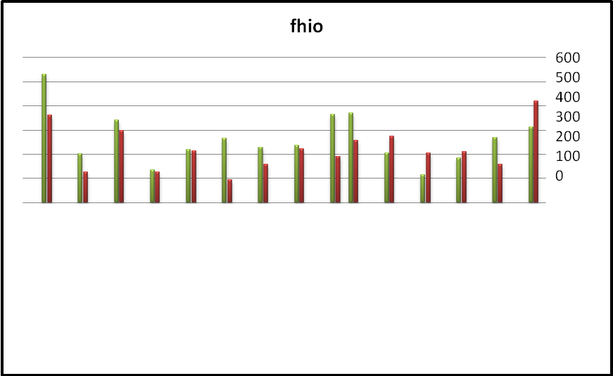
Chart illustrate existing and deficit of the specialized cleaning machineries
Ninawah | Kirkuk | Salah Aldeen | Anbar | Dyala | Baghdad | Babil | Wasit | Karbala | Najaf | Qadisiyah | Mothana | Thi Qar | Misan | Basra

Number of cleaning machineries should be provided actual number of specialized cleaning machineries
Fifth: lack of inclusion all citizens with service of transporting waste where the service provided amounted to (89%) out of total amount of citizens covered by the service in 2014. The following chart shows the percentage of the municipal service all over Iraq.

Sixth: all the stored waste quantity accounted on the basis of (1200 kg / person / day) has not been removed where the initial documents provided to us show the shortage to remove waste amounted (38%,4%,31%) for the years (2012, 2013, 2014) respectively. The following chart shows the amount of waste to be removed as well as the percentage of deviation throughout Iraq.

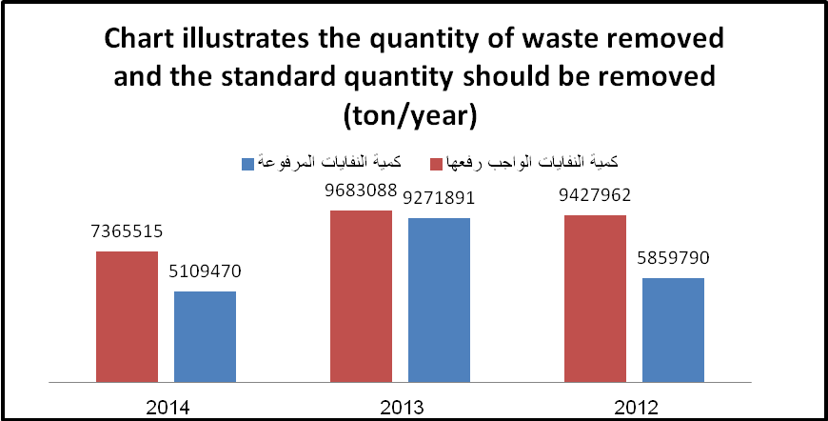
Waste quantity should be removed
Waste quantity removed

Seventh: Rehabilitation of the appropriate sanitary dumping sites in the provinces (Kirkuk, Basra) are not completed which contains the underlying cells to ensure that no leak of leachate. The work did not perform till now despite the end of the contractual period.

The impact:

The subject of solid waste management is one of the important topics because of the direct impact of waste on human health, in particular, and on the surrounding environment and general appearance in general.

The Experiences:

Technical experiences are available in the Federal Board of Supreme audit, some of them with high education degree in terms of the environmental audit to the engineers in environment, chemists, biologists and accountants holding a training inside and outside Iraq in addition to the ongoing development and training in cooperation with universities and training centers specialized in the Ministry of Planning , Ministry of Higher Education , Ministry of Science and Technology and Ministry of Environment. The following table shows the numbers and employees’ majors:

The Major | The Number
Environment engineer | 4
Civil engineer | 12
Chemist | 5
Biologist | 8
Accountant | 21
Other engineering majors | 28

The Challenges:

A- Lack of specialized environmental legislations for each activity.

B- Lack of workers' experience of the environmental activities in the FBSA's auditees.

C- Lack of units in the auditees specialized in environment which contain an integrated database regarded to the activity of each institution.

D- Diversity of offices responsible for following up environmental activities.

Conclusion :

From the above, it shows that the institutions involved in the solid waste management have not the correct strategy in the safe waste management. We noticed a weakness in the mechanism of collecting, transporting and dumping the waste because those offices are still use inappropriate places to collect the waste which are close to the residential neighborhoods and non-matching to the environmental determinants. The waste are still randomly spread near the markets, in median strips and on the main roads. Also, those institutions have not a scientific correct and clear vision in the municipal waste treatment and utilization in energy production and recycling process as well as a clear deficiencies in establishing an appropriate dumping sites according to the environmental determinants and conditions for establishing such sites to ensure the safe waste management and preserve the surrounding environment from pollution in addition to prevent spread of diseases as a result of the wrong waste management.

