**Supreme Audit office of Islamic Republic of Afghanistan**

**Vision**

“Gaining confidence and professionalism like other SAIs in the World.”

**Mission**

“Afghan SAI aims to assure the Afghan presidency, Parliament and World Community that public funds are spent as planned and the revenues are collected regularly and accounted for in financial documents; it further reports on efficiency, effectiveness and economy of government activities.”

**Objectives**

* Assessment of budgeted expenses and revenues in state departments.
* Compatibility of financial activities of those state departments or other organization which use or have public assets, with legal documents.
* Transparency in accountability of state departments or other organizations which use or have public assets.
* Protection form public assets through control and audit.
* Assurance from effectiveness and efficiency of works of other organizations which use or have public assets.
* Determining ineffective, inefficient, unprofitable and uneconomical works and incorrect financial activities, as well as recommend corrective actions for it.

**Introduction**

SAI established on 1942in Afghanistan and it was working under Administrative Office of the President, not independently with different names till 2001. After collapse of Taliban Kingdome, based on presidential decree dated 30-Nov-2002 the SAI was introduced as an independent organization with separate budget by leadership of Dr. Mohammad Sharif Sharifi the Auditor General of SAI. Afterwards, SAI Afghanistan has got the membership of INTOSAI, ASOSAI, and ECOSAI.

**Departments**

* Chief of Staff
* Policy and Plan Directorate
* Central Budgetary Entities Audit Directorate
* Organization & Enterprises Audit Directorate
* External Grant Audit Directorate
* Performance and Environment Audit Directorate
* Finance and Admin Directorate
* Construction Affairs Audit Directorate
* Internal Audit Directorate
* Human Resource Directorate
* Information and Public Communication Department
* Information Technology Department
* Foreign Relation Department

**Performance & Environment Audit**

Article 5 of new Supreme Audit Office law provides that Afghanistan Supreme Audit Institute is authorized to audit the performance of government offices, enterprises, projects and other activities so that to assure that 3Es (Economy, Efficiency, Effectiveness) are attained.

Article 2, para 5 of this new audit law clearly points out that the performance of offices considering economy, efficiency and effectiveness should be done by SAI of Afghanistan.

Since Performance an Environmental Audit department (PEAD) of SAI of Afghanistan is a newly established department within the SAI, it didn’t have a lot of experience in conducting environment audit. Having said that PEAD is a newly established department, it always considered economy, efficiency and effectiveness of operations of entities in its audits.

PEAD has conducted Environment and Performance audit in Kabul Municipality on December 22, 2014.

**Challenges in Environment and Performance auditing in Afghanistan**

* **General problems:** the challenge of performance and environment audits is an emerging issue that has received little attention by researchers. The reviews in performance audit are not limited to the financial accounting, but also include evaluation of the organizational structure, standard of procedures, operating methods, and any aspects in the organization that individually or together, have an impact to the organization’s performance**.**
* **Security:** Performance and environment audits mostly deals with site visiting to locate the deficiency in real on which bases the audit
* **Lack of professional Environment and performance auditors:** the department as previously mentioned is newly established, therefore, the previous auditors who are not much majored in performance and environment audits, are led to conduct the performance and environment audits. Since these audits doesn’t merely focus on one specific area and its coverage includes all aspects and fields, the professional auditors specified for specific audit is a prominent need.
* **Unawareness of audited entities of Environment and performance audits:** having said that PEAD is newly established department and audited entities as prevalent practice are familiar with financial and compliance audit, much result can’t be obtained through conducting the environment audit.
* **Inadequacy of Human Resources in PEAD:** Currently the performance and environment audit department has only 13 staff and it is not sufficient to expand the audit coverage.

**Audit activities undertaken by SAI**

In 2014 PEAD has conducted a joint audit of performance and environment audit of two hospitals in Ministry of Public Health.

In 2014 PEAD has conducted a joint audit of performance and environment of Kabul Municipality.

**Audit objectives**

* Legal framework, strategy, implementation of environmental standards, and waste management.
* Waste management, greenery activities in compliance with economic, effectiveness and efficiency principles.
* Legal framework and management approaches for preventing air pollution, and damaging factors to the environment.
* Approved budget, issued appropriation, procurement plans, administrative and organizational structures (e.g. effective and efficient use of human resources), developing human resource, assessment of the internal control system, internal audit, strategic, expenditure plans and to ensure compliance of the activities with economic, effectiveness and efficiency principles.

**Audit Criteria**

The extend in which the budget has been spent considering the approved budgets, issued appropriation, ability of the personal, nature of performances, activities and deals regarding the preventing air pollution, factors damaging the environment, maintaining safe environment, observing the environmental standards, waste management, efforts regarding greenery and work maintenance and the extend of utilization of the fund considering the allocation of budget, activities on cleanliness in 22 districts of Kabul city, cleaning the canals, greenery, and road maintenance covers the activities of environment audit in Kabul municipality which are based on performance audit standards driven from ISSAI (300, 3000, 3100, 3200, and also based on the environmental audit standards as in ISSAI (5110, 5120) in accordance with the procedures, laws and environment rules.

**Audit methodology**

Kabul, the capital of the beloved Afghanistan is one of the most populous cities of country with above 5 million populations most of which has immigrated from the provinces and this number is rising considerably.

The number of population imposes more pressure on Kabul Municipality to have more projects for providing social services and facility to a rising population. The services provided by the Kabul Municipality includes environmental hygiene, environmental health, waste management, establishing refineries, building roads, canals, discharge of wastes, establishing sidewalks, markets, public parks, gardening and greenery activities, removal and burial of wastes and etc. that are considered very important for the citizen’s welfare.

Considering the importance of Kabul Municipality, it was decided to conduct the performance and environment audit throughout the directorates of (Cleaning, Greenery, and Maintenance) and other relevant activities.

The performance and environment audit methodology includes accurate assessment of the documents and financial transaction of the Kabul Municipality and its 3 related units, evaluation and analysis of financial information, other information and assessment of its performance and environment audit on the basis international environment standard, comparison of their activities with the performances of other countries, receiving the opinions and recommendation of the Kabul Municipality authorities regarding the audit findings, recommendation, numbers and orders, sites visual audit and interviews with the citizens of districts number 1, 4, 7, and 11.

**Performance audit in Ministry of Public Works**

Streets construction Master Plan, June 2015, provides that ministry of public works, municipality and ministry of rural rehabilitation development are responsible for constructing streets. MPW is responsible for construction of roads between provinces.

**Audit findings**

1. Visual control conducted from different areas by audit delegation and found that rills were cleaned but wastes were not transferred. Gill (fish meat) and meat seller sale meat closed to dirty full of mud rills which spread different diseases, Directorate of Environmental has not taken any action regarding to issue.

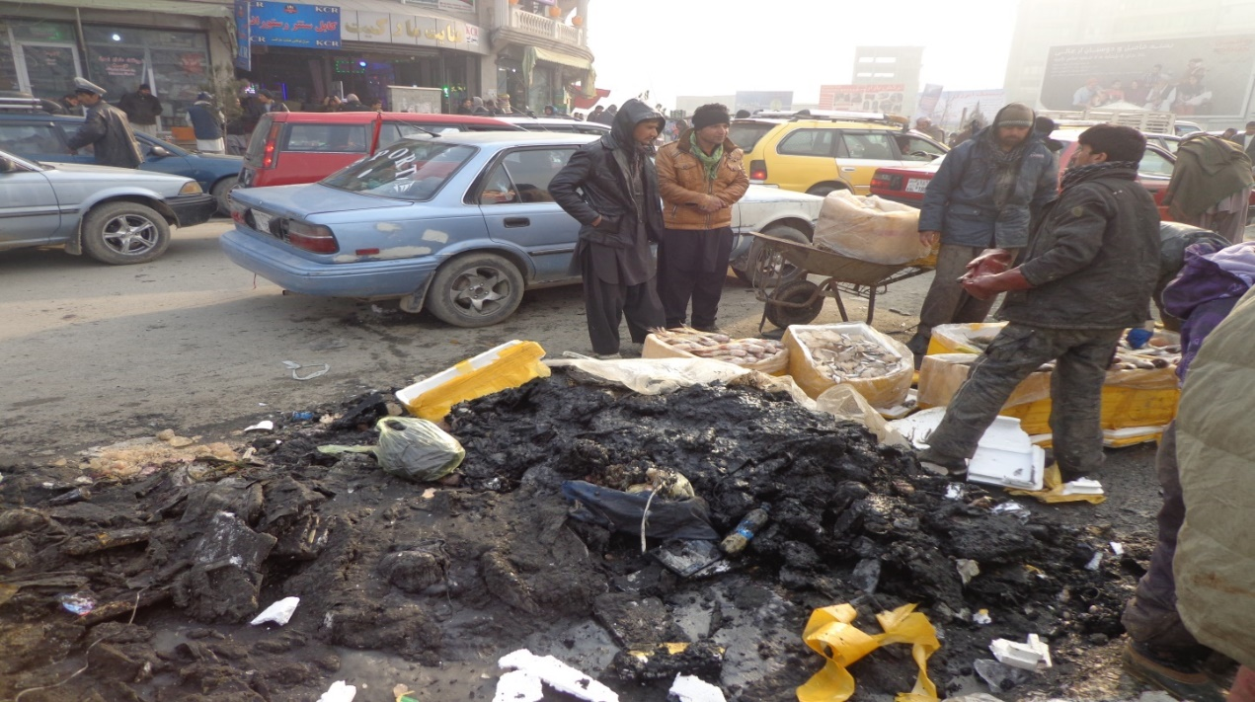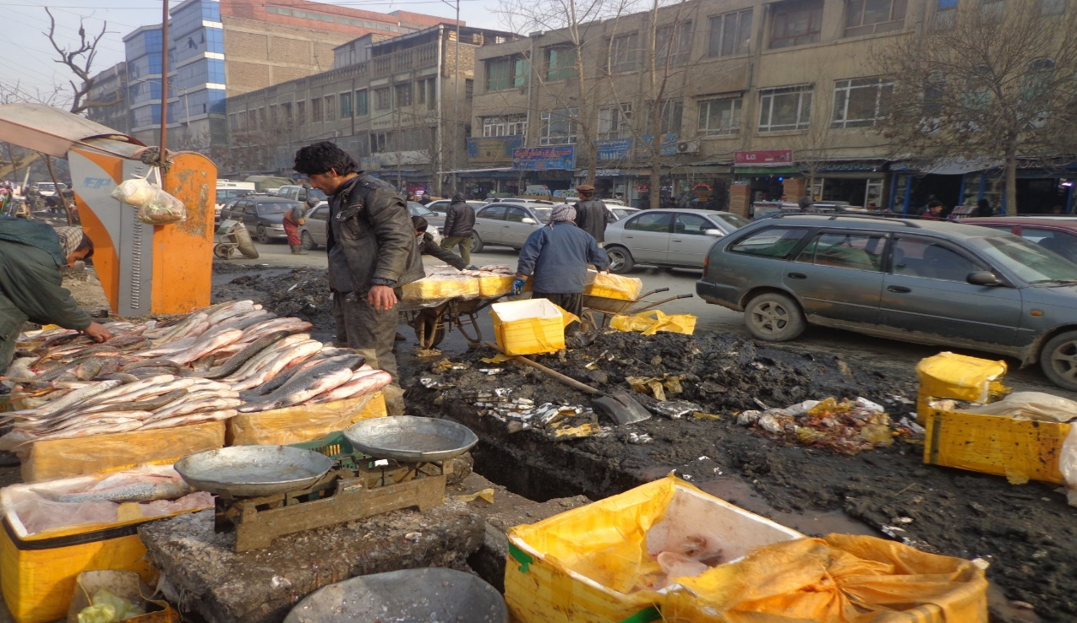

**Recommendation**

Kabul Municipality must direct and guide Directorate of Environmental Health and Environment Protection to consider health issues and transfer waste materials from Nadir Pashtoon Avenue with assistance of groups who are responsible for cleaning of food, environment and city. They must strictly control and monitor area to prevent from spreading of different diseases and pollution of environment.

1. **Kabul River placed huge amount of Trash**

Kabul River has water only for a few months when the weather is rainy but for the rest of the year it is dry. The river from which people were enjoying has changed to a public waste hub of Kabul city. People throw and pour any trash or waste in it. But it is regret that people and the officials don’t take it serious and not considering the results afterward. Some governmental organizations are also involved in pollution of Kabul River and despite the complaint and information that was broadcasted by media, that haven’t taken any action. Because Kabul River ends to areas such as Mahipar, naqlo and Sorobi, and the wastes are collected out of the city this will make a big problem to dumps and electricity firms.

Based on survey conducted by Kabul Municipality, it was noticed that there are approximately 1835 sub-pipes and home sewerage led into Kabul River that pollutes the underground water.

The trash and sewerage in Kabul River will all gather together in an area outside the city namely Sorubi and will produce poison and prohibits utilization of water resource for production of power.

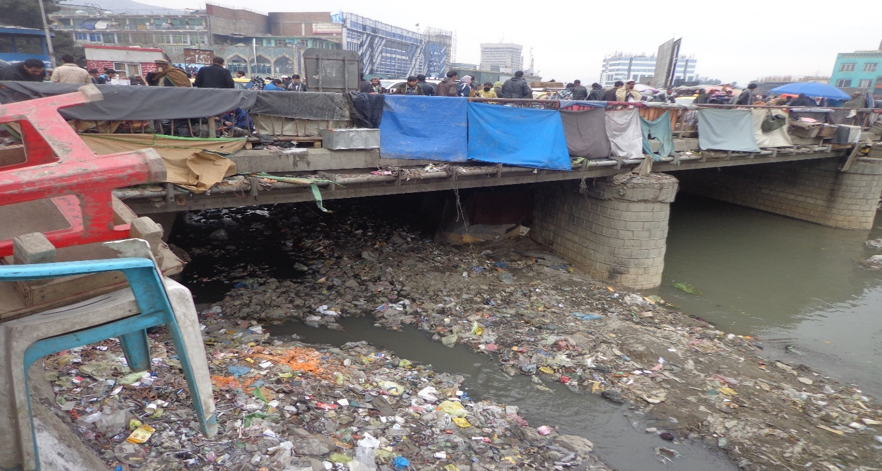

**Recommendation**

Kabul Municipality should order Directive of Cleaning and first District to develop a plan for cleaning of Kabul River and organize the markets, shops, venders, confectionaries, and common bathroom and do their responsibilities with coordination of security entities so that we can prevent from this mess and lack of hygiene’s.

1. **Fourth district of Kabul Municipality:** as per the committee observation from fourth district in Sarak Chehl Metra in front of Salam University, market area, below Sarak &0 Metra Saray Shomaly, in front of Pahlawy Masjid, wastes and garbage’s haven’t been carried for the last twenty days and people face problem while commuting.

The committee asked Kabul Municipality through inquiry # 29 dated 17/5/1394 about cleaning and digging the cannels, rills during 1391-1393, and Kabul municipality replied in regards that have planned cannels in different areas of Kabul City to prevent the stoppage of waters and wastes and it is going to be implemented by Directorate of maintenance and these problems will be solved. And regards to waters along the Road in from to Directorate of Cleaning, KUTI has surveyed the area and the process is in progress.

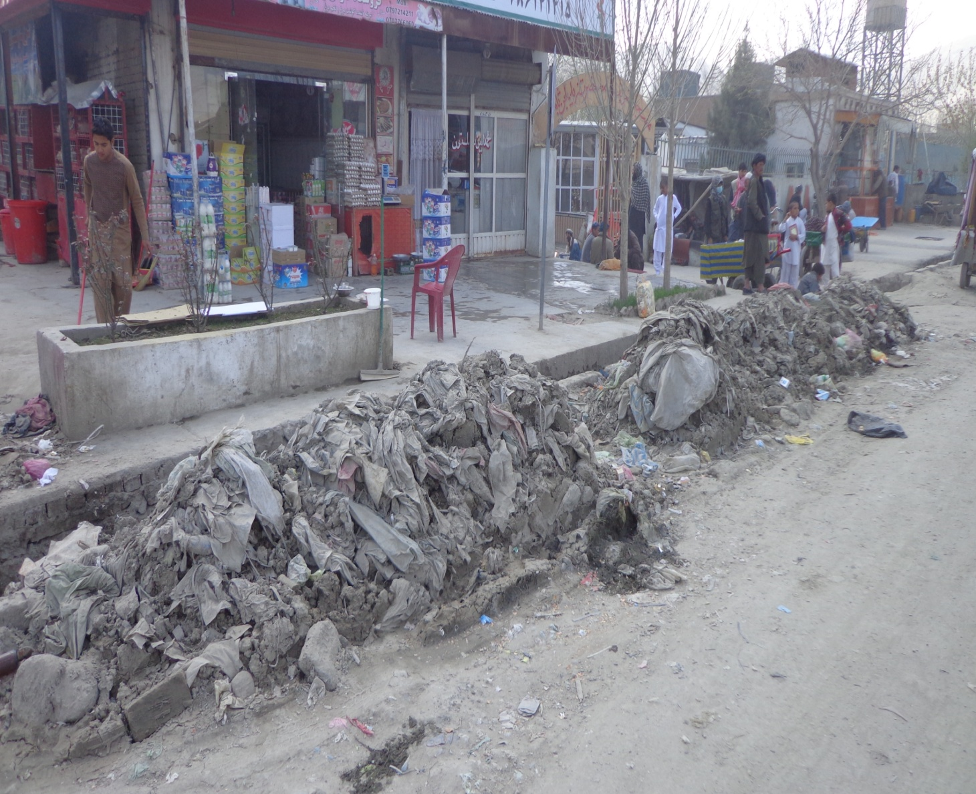

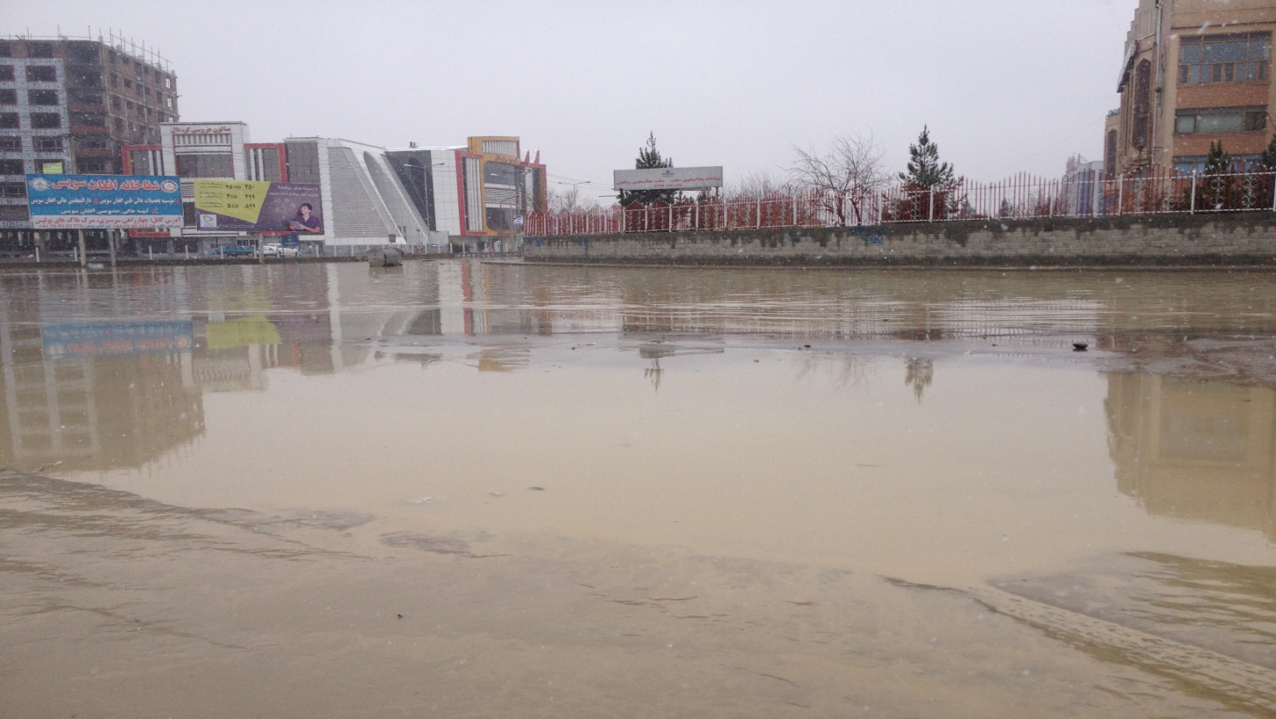

**Recommendation**

Kabul Municipality should order Directorate of Maintenance and fourth district to pay special attention in cleaning of wastes, rills and stand water from these areas specially in Sarak Chehl Metra in front of Salam University, market area, below Sarak &0 Metra Saray Shomaly, in front of Pahlawy Masjid and take special actions.

1. Kabul Municipality, went into a contract with Faqir Rahmani Construction Company for managing the sewerage into Kabul River, but it was noticed that in an area about 190 meters away from Kabul River, the sewerage was disposed of into a big puddle irresponsibly.

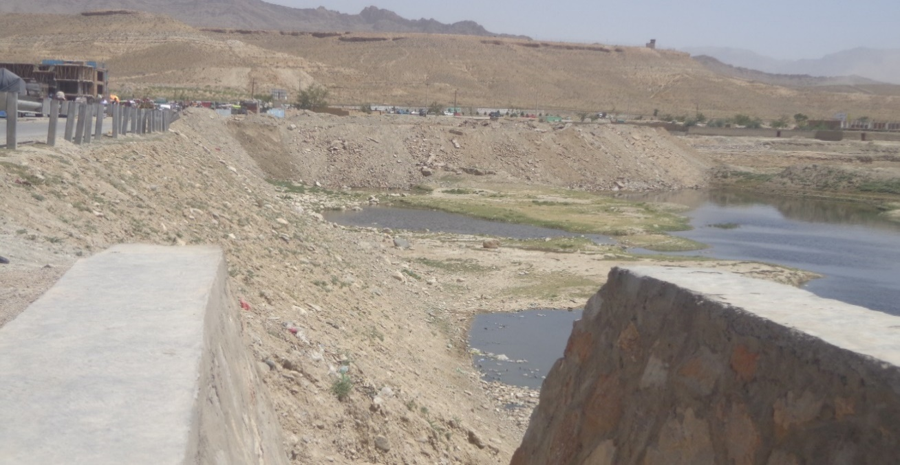

1. **Packs of Homeless dogs and Rabies**

In physical visit of auditors from different districts in Kabul city, a lot of homeless dogs were seen.

Rabies is a highly fatal disease that the infected person will hardly be cured and mostly dies. Lack of an effective program for removing homeless dogs and having no exact statistics about the number of cases of bitten dogs severed the situation.

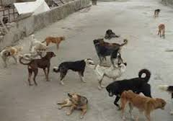

**Recommendation**

Kabul Municipality is responsible to do the following activities:

* Preparing boneless meat of cow according to need
* Making prey in perfect predetermined area from remote access of people
* Distribution of prey which is made in accordance of special condition of health protection
* Collecting corpse of died mad and swinger dogs in morning before sunshine
* Burying corpse in safety areas
* Collecting remaining preys

**Best Regards**

**SAI Afghanistan**

Mr.Ahmad Shekib Kardoost

Mr. Asadullah Hamidi

Mr. Shawkatullah Azizzi